Nottingham Trent University

School of Science and Technology

Healthify

by

Hamid Mujtaba

in

2020

Project report in part fulfilment

of the requirements for the degree of

Bachelor of Science with Honours

in

Software Engineering

I hereby declare that I am the sole author of this report. I authorize the Nottingham Trent University to lend this report to other institutions or individuals for the purpose of scholarly research.

I also authorize the Nottingham Trent University to reproduce this report by photocopying or by other means, in total or in part, at the request of other institutions or individuals for the purpose of scholarly research.

Hamid Mujtaba

Abstract

Enter abstract here. The abstract should include: A) Brief statement of problem B) Brief exposition of methods and procedures and C) Brief summary of findings.

After the title, the abstract is the next level of detail regarding your work. The scientific community relies on 'The Abstract' as the main means of communicating research interests. There are many collections of abstracts published from which interested parties can trace the original work. They form the first step in a researcher's quest for up to date information regarding work being carried out worldwide.

The abstract is a one A4 page, 1.5 Line Spacing, retrospective account of the achievements, techniques and conclusions of the report. On no account are you to exceed one page. Do not go into a great long explanation of the general area, be very precise and stick to what you have achieved. This is filed by the library and enquirers from other institutions are sent a photocopy of this single sheet and thus immediately assess the work's relevance to them. They will know about the general subject area and its problems; what they want to know is whether you have found a solution. Be sure to include as much relevant information as possible on that page.

The abstract is very much an impersonal, factual, retrospective account of your finished project as might be written by somebody else. The tone of the English might be 'The work introduces the general area of..... and then investigates an apparently new method for..... The method is partially successful in that it...... '.

Acknowledgements

Enter acknowledgements here. It is usual to acknowledge those that have assisted you in your work and will normally include your main project supervisor. The order of acknowledgments (most important first) and their respective length indicates their relative importance to you.

Table of Contents

Abstract ii

Acknowledgements iii

Table of Contents iv

List of Figures viii

List of Tables xi

CHAPTER 1 1

Introduction 1

1.1 Introduction 1

1.2 Aims and Objectives 1

CHAPTER 2 4

CONTEXT 4

2.1 Introduction 4

2.2 Literature Review 4

2.2.1 Health Risks Associated with Obesity 7

2.2.2 Solution to Obesity Epidemic and Benefits of Exercise 8

2.2.3 Health and Technology 10

2.3 Current Solutions 10

2.3.1 Exergames 11

2.3.2 Wearable Technology 12

2.3.3 Active Notts (Website) 13

2.3.4 Smartphone Applications 14

2.3.5 Comparison 21

CHAPTER 3 28

New Ideas 28

3.1 Introduction 28

3.2 Proposed Solution 28

3.2.1 Application Features 28

3.2.2 Project Requirements 39

3.2.3 Software Requirements 42

3.2.4 Project Schedule 47

CHAPTER 4 51

IMPLEMENTATION or INVESTIGATION 51

4.1 Introduction 51

4.2 Methodology 51

4.2.1 Agile Scrums 51

4.3 Design 52

4.3.1 Use case diagrams 52

4.3.2 Database Structure (Firebase) 54

4.3.3 User Interface Design 55

4.3.4 System Architecture 60

4.4 Development 61

4.4.1 Version Control 61

4.4.2 Scrum Board 62

4.4.3 Sprint 1 63

CHAPTER 5 72

RESULTS / DISCUSSION 72

5.1 Introduction 72

5.2 Functional Requirements Testing 72

5.3 Compatibility Testing 75

5.4 User Testing 78

5.5 Limitation of the Solution 79

CHAPTER 6 80

CONCLUSIONS / FUTURE WORK 80

6.1 Conclusions 80

6.2 Future work 80

6.3 Legal, Social, Ethical and Professional Issues 80

6.4 Synoptic Reflections 80

ReferenceS 81

Bibliography 82

Appendix A: Project Planning document 83

A1 Introduction 83

A2 Amins and Objectives 85

A3 Tasks and Deliverables 86

A4 Gantt Chart 90

A5 Resources 91

A7 Project Risks 92

A7 Legal, Social, Ethical and Professional Issues 95

A9 References 98

List of Figures

Figure 1: Adults Effected by Obesity 4

Figure 2: Rate of Obesity Over the Years 4

Figure 3: Kids in Reception Effected by Obesity 5

Figure 4: Kids in Year 6 Effected by Obesity 6

Figure 5: Login Screen 29

Figure 6: Register Screen 29

Figure 7: 'User Targets' Screen 30

Figure 8: BMI Test 30

Figure 9: Fitness Tracker Screen (2) 31

Figure 10: Fitness Tracker Screen (1) 31

Figure 11: Outdoor Activities 33

Figure 12: Activity Info 33

Figure 13: Select Type of Activity 33

Figure 14: Indoor Activities 33

Figure 15: Daily Challenges Screen 34

Figure 16: Beginner Challenges Screen 34

Figure 17: Chat Room Screen 35

Figure 18: Gantt Chart 49

Figure 19: Scrum Framework 51

Figure 20: UML Use Case Diagram 52

Figure 21: JSON Database Structure (Firebase) 54

Figure 22: Logo for the Application 55

Figure 23: User Interface (Home Screen) 56

Figure 24: Google Material Guidelines - Bottom Navigation 57

Figure 25: System Architecture Diagram 60

Figure 26: GitHub Repository for Project 61

Figure 27: Scrum Board (Sprint 1) 62

Figure 28: Project Gradle File 63

Figure 29: Firebase Database Setup 64

Figure 30: Login Details Validation 65

Figure 31: Validation on Registration Screen 66

Figure 32: Detailed Activity Screen 67

Figure 33: Outdoor Activities Screen 67

Figure 34: Application on Samsung Galaxy Note 10 Plus 75

Figure 35: Application on Google Pixel 76

Figure 36: Application on Google Nexus 5x 77

List of Tables

Table 1: Comparison of Existing Solutions 20

Table 2: Resources Required for the Project 39

Table 3: Project Milestones 47

Table 4: Functional Requirements Testing 71



Introduction

Introduction

The focus of this project is to promote a healthier lifestyle through a smartphone application by encouraging individuals to exercise more and help to implement healthy habits in their lives.

Over the years, technology has greatly improved and made lives easier. Technology is being used in nearly every sector, from construction to medicine, and by every kid, teenager, and adult in their daily lives. However, technology has a lot of negative impacts associated with it; excessive use of technology is making people lazy, making them less active and affecting their well-being. For this reason, technology is known to be pervasive, however in the past few years, innovative ways of using technology to benefit people’s well-being have been sought. The lack of exercise in our society has led to an increase in a lot of health-related diseases/illnesses such as heart disease and obesity, as well as playing a big role in other medical conditions. As a result of this, there are now countless smartphone applications and many fitness equipment (i.e., smartwatches) made available to people in the hopes of helping them stay healthy and improve their overall well-being.

Unfortunately, even with this growing innovation of resources and research being conducted to find more efficient ways to improve our health, statistics (refer to Figure 2) show that obesity is still increasing over the past couple of years instead of decreasing. This suggests that, although there are now advanced technical resources in place to benefit people, these are mostly used by those who already engage in physical activity. Through my research, it has been discovered that the general populace does not interact with or use these resources. The main reason for this could be how the average person would not know how or where to start getting into exercising, as they lack the relevant information regarding a healthier lifestyle. Another reason could be lack of motivation, which can also be linked with the first reason; as they do not have all the information available to them, they will therefore struggle to find motivation. This results in many people giving up on trying to achieve a healthier lifestyle after only minimal browsing.

Aims and Objectives

This project aims to develop a smartphone application which will encourage and help motivate individuals live a healthier lifestyle. It will contain all the necessary information they will need to improve their well-being such as; different physical exercise, indoors and outdoors; how to manage weight; managing calories intake and other beneficial healthy habits. It will focus on different ways to keep the users motivated and engaged over time, helping them reach their goal of living a healthier lifestyle. The project will take inspiration from popular fitness applications and will look to improve on the features already available by developing a solution which will aim to focus on the areas they are lacking in.

The roadmap to the rest of this document, Chapter 2: Context will analyse existing research and solutions promoting healthier lifestyle. It will also identify the limitations of the current solutions and how to overcome them. The following chapter, Chapter 3: New Ideas will propose a new solution, taking the research done in the previous chapter into consideration, by building on and improving on strong features identified in chapter 2. Chapter 4: Implementation documents the process of the designing and implementation of the proposed solution. Once the proposed solution has been implemented, Chapter 5: Results/Discussion will analyse and discuss the results of testing and evaluation carried out on the implemented solution. The final chapter, Chapter 6: Conclusions/Future Work reflects on what has been learned and summarise the success of the project, in addition to briefly discussing any potential improvements and/or future work.



CONTEXT

Introduction

This chapter will present and discuss the research done on the topic and existing solutions promoting healthier lifestyles. The literature is then analysed and examined further to identify limitation of the current solutions.

Literature Review

The project will tackle physical health issues in the UK due to lack of exercise. According to the research done by NHS (July 2012), a lot of health issues in the UK are due to the lack of exercise which is “as deadly as smoking”. It has been estimated that “one in 10 cases of heart disease (10.5%) and just under one in five cases (18.7%) of colon cancer in the UK” often can be due to lack of exercise. In 2008, inactivity caused more than 5.3 million of the 57 million deaths estimated worldwide (NHS 2012). Lack of exercise can also cause the bones to become weak, risk of diabetes or hypertension (Kristin Davis, n.d). However, over the years, health issues relating to lack of exercise didn’t decrease; obesity being one of the main concerns. Obesity is a medical condition where a person is overweight and carries unhealthy amount of body fat which influences their health. In a very recent article by NHS (May 2019), during 2017/18, there were 10,660 patient admissions who had illnesses directly relating to obesity and 711,000 where obesity was “primary or a secondary diagnosis”; which is very similar to the statistic recorded in 2016/17 (10,705). Obesity was more common in female adults than it was in male adults. For every 4 patients, 3 were female (74%) for illnesses directly relating to obesity, and around 2 in every 3 (66%) for illnesses that had some relation to obesity. The 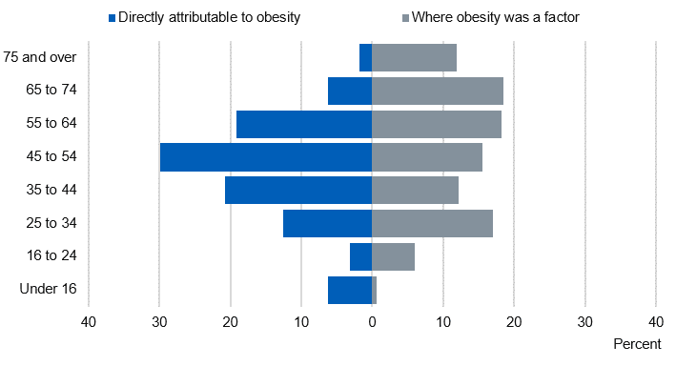statistics show that obesity was commonly found in adults aged between 35-64.

Figure : Adults Effected by Obesity

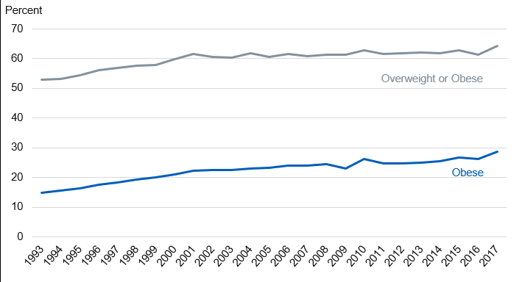“The majority of adults in England in 2017 were overweight or obese (64%)” and the percentage of obese adults was “29% higher than in recent years” (NHS 2019). The percentage of obesity increased “steeply between 1993 and around 2000” in England, however, the rate of increase became slower after that.

Figure : Rate of Obesity Over the Years

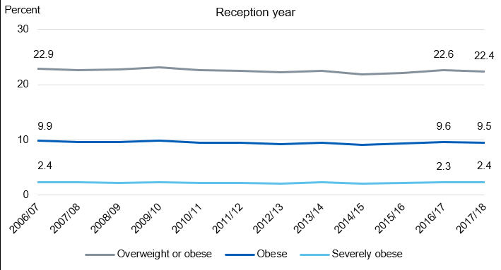This suggests that despite NHS knowing the increase of obesity throughout UK for a very long time, and researchers having come up with solutions to tackle this issue, they could not decrease the amounts of patients being admitted into hospitals due to obesity; instead, the numbers were gradually increasing with time – nonetheless, they did manage to slow it down in recent years. The research showed that not only adults are at risk of being diagnosed with physical health illnesses such as obesity, but young children too. The same article stated that in 2017/18 prevalence of obesity in year 6 children has increased by 1% compared to 20.0% in 2016/17 (Fig.4). For children in reception the percentage did not change much and was “similar at 9.5% in 2017/18” (Fig.3). However, compared to 2006/07 the percentage is lower for children in reception but is higher for kids in year 6 (NHS 2019).

Figure : Kids in Reception Effected by Obesity

### Health Risks Associated with Obesity

Figure : Kids in Year 6 Effected by Obesity

If someone is even 40% overweight, they are “twice as likely to die prematurely” compared to an average weight person (Robert 2017). This this because obesity is a serious health hazard has a high chance of leading to other health problems. Some of the serious health conditions include; heart disease and stroke, high blood pressure, diabetes, cancer, gallbladder and gallstones, breathing problems such as asthma and apnoea just to mention a few. Heart disease and stroke are known to be the leading causes of death/disability according to research done in the U.S (Robert 2017). Being overweight can increase the risks of high blood levels of cholesterol which often leads to heart disease. It can also lead to angina (pain in the chest caused by decreased oxygen to the heart) and sudden death. Type 2 diabetes is one of the two major types of diabetes which is a major cause of early death as well as heart disease, stroke, and blindness, which reduces the body’s ability to control blood sugar. Being overweight can increase the risk of getting type 2 diabetes by two times. Gallstones are small stones in the gallbladder. In most cases, they do not need to be treated, however, if it becomes trapped in an opening inside gallbladder, it can cause intense pain in the tummy. Gallstones are very common in the UK as it is estimated that “more than 1 in every 10 adults in the UK has gallstones” (NHS 2018). Research shows that the individuals who are likely to develop gallstones are overweight/obese, a female or 40 (and over). According to cancer research UK (2018) “more than 1 in 20 cancer cases are caused by excess weight” in the UK and being overweight/obesity is the second most preventable cause of cancer. There are many types of cancer which is caused by excess weight such as breast cancer (in women), bowel, womb, kidney, liver, meningioma (type of brain tumour) etc. Men are more likely to develop colorectal cancer and prostate cancer. This includes breast and bowel cancers which are the most common types of cancer, and pancreatic, oesophageal and gallbladder cancers, which are the most difficult to treat (Cancer Research UK, 2018). Increasing the amounts of physical activity can help reduce weight, which in turn will decrease the chances of developing the diseases mentioned.

### Solution to Obesity Epidemic and Benefits of Exercise

There is no simple solution or strategies to prevent diseases such as obesity. It’s a very complicated problem therefore a multifaceted approached must be taken. Contrary to what some people think, key to “maintaining a healthy weight isn’t short-term dietary chances changes; its about a lifestyle that includes healthy eating and regular physical activity” (Centers for Disease Control & Prevention, 2019). Patients of such diseases are also advised to lose “weight safely by eating a healthy, balanced diet and regular physical activity” by their GPs (NHS, 2019). To lose weight at a safe and healthy rate, people are advised to reduce their calories intake by 600 per day. The exact amount will vary between men and women. For men, they are recommended to consume 1,900 calories maximum a day, and 1,400 calories (a day) for women. A healthy diet should include lots of fruit and vegetables, plenty of starchy foods (such as bread, rice, pasta etc), milk/dairy foods, non-dairy sources of protein (such as fish, meat, eggs etc), and small amounts of food/drinks which contain high fat and sugar. It is important not to consume foods which contain high levels of salt as they can raise blood pressure, which can be dangerous if you are already obese. However, it is advised to avoid fad diets as they are unsafe and could make you ill. Managing your calories intake will help you lose weight, however maintaining that healthy weight will require you to do some physical activity to burn energy. According to NHS (June 2018), exercise “can reduce your risk of major illnesses, such as heart disease, stroke, type 2 diabetes and cancer by up to 50% and lower your risk of early death by up to 30%”. Physical activity isn’t only beneficial for those who wish to maintain healthy weight, but “it can help prevent and manage more than 20 conditions, such as reducing the risk of type 2 diabetes by 40%” (NHS, 2019). It is recommended by the Chief Medical Officers for an adult to do minimum of 150 minutes of activity a week (moderate intensity). Brisk walking, cycling, and dancing are all examples of moderate-intensity activity, where the activity increases your heart rate. Alternatively, to push yourself further, you could do 75 minutes of vigorous-intensity activity every week, where your heart beats very fast and breathing gets hard. Examples of vigorous activity include, running, jumping rope, most competitive sports or hiking uphill etc. To prevent obesity, it is recommended to exercise longer each day or regaining weight. 45-60 minutes of moderate-intensity activity a day is recommended to prevent obesity, and 60-90 minutes of activity each day to avoid regaining weight. Parents are advised by GPS that “children over the age of 5 should ideally get at least 60 minutes of vigorous-intensity exercise a day” and idle activities such as playing games or watching TV should be restricted (NHS, 2019). According to research, it is medically proven that people who do regular exercise have up to a 35% lower risk of coronary heart disease and stroke, 50% lower risk of type 2 diabetes, 50% lower risk of colon cancer, 20% lower risk of breast cancer, 30% lower risk of early death, 83% lower risk of osteoarthritis, 68% lower risk of hip fracture, 30% lower risk of falls (among older adults), 30% lower risk of depression and 30% lower risk of dementia (NHS, 2018).

### Health and Technology

People have become less active in the modern age, partly due to technology as it has made our lives easier. On the other hand, technology has also been benefiting us as it has played a big part in improving healthcare and revolutionised the way we exercise. Some of the benefits technology has brought to healthcare include better treatments and equipment which enabled doctors to provide better care and help treat long-term illnesses, improving the quality of life of many people. Better equipment has also allowed doctors to research medicine more efficiently which has helped find treatments for some life-threating illnesses. It has made it easier for physicians around to world to share their finding and information of their research; patient records are stored into cloud database which the doctors can access any time to view in-depth medical information of the patient. Technology has made it a lot easier to identify diseases and help with disease control with the use of new, advanced software. This has allowed “World Health Organization [WHO] to classify some illnesses, their causes, and symptoms into a massive database that has more than 14,000 individual codes” (Awais dar, 2018). This data can then be accessed by medical professionals and researchers which allows them to control disease and improve healthcare.

## Current Solutions

Technology is also playing an active role in promoting exercise in the form of exergames, wearable technology and mobile applications. Exergames was mostly targeted at children and teenagers as they were known to spend majority of their free time playing games instead of going out, but now it also attracts adults as there are a variety of games targeting them. However, exergaming is not the cure for inactive lifestyle, but is a mean to motivate people who do not to do any form of physical activity, to exercise. The engaging nature of the game makes it enjoyable for everyone which is perfect for people who struggles to do any exercise because with other forms of exercise, they would think how tired and exhausted they are, but with exergames, their mind will be occupied in the game and how much fun they are having. Exergames can help you burn as many calories (or more) as brisk walking and can be beneficial to people who have been diagnosed with type 2 diabetes or obesity. These games also allow interaction between other players where you can play together with you family or friends which further helps motivate the person.

### Exergames

Dance Dance Revolution (DDR) is a very popular and one of the best examples of exergames. It is a perfect alternative to outdoor physical activities such as running, cycling, and swimming. DDR is available on the console and can be played using a dance pad/mat. It also has a workout mode where the user can choose from workout time or calorie burn mode. Workout time allows you to have a session which can last up to two and a half hours. There are different difficulty modes the user can choose from, beginner mode, intermediate, and advanced. The calorie burn mode allows the user to pick the number of calories they would like to burn during that session. It’s recommended to select somewhere in between 300-750 calories. During each stage in the game, it will display how many calories the user has burned (or the session time remaining) and will also display the equivalent of how much you have run. Wii Sports in another great example of exergame which was produced by Nintendo for their console, Nintendo Wii. It included five different games, tennis, golf, bowling, boxing, and baseball, which can be played using a wireless, handheld controller which detects the players movement and mimics them. For example, for the baseball game, the user will need to swing their control and time it correctly to produce the swing of the bat on the screen. Although Wii Sports will not help players burn as many calories as playing an actual sport, it can help them keep fit.

### Wearable Technology

Wearable technology has also started to become a trend which helps promote exercise, i.e. smart watches. It has many features such as pedometers, which counts and monitors the number of steps you have taken throughout the day during activities such as walking or running etc; accelerometers, which records the body’s acceleration per minute and provide a detailed report on the frequency; heart rate monitors which are used to monitor the exercise intensity which can be very useful for people in cardiac rehabilitation programs or athletes. Wearable technology such as smart watches provide different features depending on their manufacturer. Examples of smart watches which promote exercise include Honor Band 4, Xiaomi Mi Band 3, Germin Viviosmart 4, Fitbit Charged 3 and Polar Vantage M and Polar Vantage V. Honor Band 4 and Xiaomi Mi Band 3 both provide basic fitness features such as monitoring your step count, distance travelled, floor climbed and calories. Some versions of the watches also include built in heart rate monitors which help monitor whether you’re within fat burning zone or not. They also have built-in GPS, or like most watches, have the ability to get GPS data from the phone. Motivational reminders where it will vibrate to remind you to start moving, also has the features to set up goals (e.g. step count). For people who have unhealthy sleeping habits, there is a sleep tracker which will help you monitor whether you are getting enough sleep. Vantage M and Polar Vantage V are more advanced therefore include extra features compared to other smart watches. These watches include a barometer and recovery measurements to ensure you are not overtraining (or if the training isn’t intense enough) by monitoring the intensity, volume and frequency of the training. Provides you with a more in-depth running data to help you develop and balanced and steady running style by giving you information on ground contact time, balance, stride length, cadence and vertical ratio. Also provides an analysis on training load and how challenging a session is compared to other workouts. Comes with jump and orthostatic tests where it tests the strength of your leg muscles and display how your heart rate training.

### Active Notts (Website)

There are a lot of solutions available online and on mobile which promote exercise and a healthier lifestyle. For example, ‘active notts’ is a website which contains information on every sport/physical activity to help people with their health issues. It allows the user to search for the sport by typing the name of the sport in the search bar, alternatively, they can search for sports which can help them with their certain health conditions. For example, they can type ‘Mental health’ in the search bar and the website will display every sport which can be useful for people with mental health. When the user clicks on the sport, the website displays an overview of the chosen sport which can be very useful for people who are not familiar with the sport. It also displays benefits of the chosen sport, costs which the user may need to take into consideration (e.g. equipment, kit etc), how to get involved/started, equipment the user will need and interesting facts about the sport. At the bottom of the page, users can search for opportunities available in their area (or within their chosen radius) where the website will display all the clubs/facilities available for the sport. The user can filter the search result by date, gender, skill level, age range, family friendly, disability etc. When the user clicks on the club/facility, the website will then display brief description of the club, contact details, and the location. The website doesn’t just contain information about all type of sports but physical activities as well. It displays a variety of activities from chair-based exercises, Walking, Gardening, Yoga to CrossFit, Dance and Qigong etc. When the user clicks on activities, they process and options they are given are the same as when they click on a sport, as they can search for opportunities, filter them etc. This website is great for anyone who wants to get started playing a support but has no prior knowledge on it.

### Smartphone Applications

Mobile applications play the biggest role in revolutionizing exercise, because mobile phones are the most commonly used and easily accessible piece of technology available, thus gives exposure to a large audience which can be influenced. According to Lauren Pufpaf (2019), since the launch of iPhone in 2007, fitness apps have grown and there were “nearly 320,000 health and fitness apps in the app stores in 2018”. There are all types of fitness application available for free which offer similar features (and more) to smart watches and other fitness technology available. There are apps which allow you to track and monitor your sleep, plan your workout sessions, provide analysis on progress, track your calories intake, audio-based workouts and much more. Majority of these apps are free of charge, allowing anyone interested to take part, for example, there are apps which create daily/weekly workout plans for you and act as your fitness instructor. These applications are very beneficial to those that cannot go to gym because of their financial situation or those who don’t have such facilities locally.

#### Find a Player

‘Find a Player’ is a mobile application designed to help encourage people who are not part of sport clubs to get involved by helping them find new clubs they can join for those interested in playing weekly at a competitive level. However, for players interesting in playing in their spare time as a hobby, ‘Find a Player’ allows the user to find local players for their team (i.e. 5-a-side football match or any sport) if they are short on numbers, and vice versa, they can join a team for a quick game of their chosen sport. The user can approve or decline applicants by viewing their application. This is possible as users can create their own profile where they include brief information about themselves; this also allows others to add the user as their friends and vice versa. ‘Find a Player’ also lets the players to rate one another which allows other users to determine someone’s skill level. This makes is easier for users to review applicants. This application isn’t targeted towards individual players, but towards organisers and clubs too as it allows them to register their clubs or advertise sport events and recruit players or teams. ‘Find a player’ also has a message feature where the user can talk to a player individually or create a group chat. This application is available on Android as well as IOS devices. This is great for people who don’t have a lot of free time but wish to play sport as a hobby and not regularly. So they can join someone else’s team or make one whenever they wish to play which will be great way to get friends and families involved.

#### Playwaze

Playwaze is a great app for encouraging people to get involved in a sport. It allows organisations to provide opportunities, setup and manage local, regional and/or national tournaments. Sport team owners can also create an account and register their team so they can manage their team and have a means to communicate with all the players, collect payments online, create sessions and competitions. There is also a feature which provides you with analysis and a report on participation data. Users can see the progress their players are making through their coaching. Organise fixtures between other teams or arrange quick matches. The users can also share video clips, photos or any other information on the news section. The users can also manage their teams and competitions using their website, so they don’t necessarily need to do everything on the application. This application is great for universities and schools to help promote sports to the youth.

#### MyFitnessPal

MyFitnessPal is one of the best motivational mobile applications which monitors diet and exercise. The app is mainly used for people who wish to gain or lose weight as it logs everything you eat and drink every day (from their food database). To make sure the feedback and advice it gives the user is accurate as possible, it will ask for the user’s information such as height, weight, and their age which it will use to understand if the user is overweight, underweight and what type of recommendations are needed for the user to get to their desired weight. The application has a unique feature where after you have finished logging food on the app, it will tell you what your weight will be like by a certain date (e.g., in 1 months or 6 months’ time) if the users food intake everyday (until that specific date) was the same. This helps motivate the user as they can visualise and see the end result before reaching it, so it gives them that extra push to stay motivated and focused to reach their goal. However, if you skip were to not focus on your calories intake and had way less or way more than you should, then it will display an error message saying it would be dangerous if the user’s food intake everyday was like today. MyFitnessPal also lets you add in your custom recipes which will give the app the most accurate representation of your calories intake; users can keep their recipes as private or add to the public database. MyFitnessPal offers more premium features for users but will need to pay to gain access to them. One of the premium features is that the users will start getting videos with short workout summaries which contain inspirational interviews. There is also a community for the users where they can talk to fellow users, share success stories, talk about different recipes and experiences.

#### Endomondo

Endomondo is a motivational mobile application which aim to “motivate people to get and stay active”. It is designed to track workouts, provides users audio feedback, and offers guidance on how to reach their goal. It is a personal training app which also syncs with their website where the users can view their training log and analyse their fitness activity. Endomondo helps make fitness plan for the user and sets targets for them to chase no matter what type of exercise you chose, whether its Running, Cycling, Football or Golfing. Once the user has set targets for their exercise, the app will give real-time audio feedback on how well the user is doing, which gives them that motivational push. The application allows users to compete against themselves and most importantly against their friends and relatives as Endomondo allows users to share their activity with other users. Users can view their friend’s activity, send messages to help motivate them or send them challenges to do. Endomondo keeps record of user’s activity and provides them information in the form of graphs and stats which allows them to see how much calories they have burned, how many miles they have logged and how quickly they are improving. Endomondo is free to use, however, it also has a premium version which gives the user access to more features such as personal training plans tailored to the user’s goal and fitness level. Endomondo access the user’s fitness level by making them do a small test first which help the app to see how fit the user is, which makes it easier to recommend fitness plans and set goals.

#### FitPlan

Fitplan is one of the best personal training mobile application available with 1.4m users worldwide. Fitplan offers fitness plans made by professional, well-known personal trainers for their users, whether they wish to train at home, or at the gym. The users are given step-by-step instructions as they follow, they daily workouts with videos; there are also tools for the users to track their weight, reps and time. There is a section called “Feed” where there is exclusive motivational content, such as other users’ motivational success stories, fitness and nutrition tips. There are different types of fitness plans available for all types of users, from “Power Shred” which helps users to shred fat and gain muscles, to “Step up Strength” which helps users to tone and tighten, helps wit “booty gains” and lose fat (this is targeted more towards women). Fitplan is also available on Apple Watch so it can sync with the app and help users track their heartrate, reps and weights more easily. However, the downside about Fitplan is that it’s a subscription-based application, thus the users will need to subscribe every month (or yearly) to gain access to the app’s content.

#### Pokémon Go

With time, exergames have also adapted to the current era and taken a step towards the right direction in the form of Pokémon GO, which is a smartphone game that has combined gaming with the real world. Pokémon is a famous, world renown Nintendo owned franchise where humans, known as Pokémon trainers, catch, train and battle fictional characters known as Pokémon (short for pocket monsters). Pokémon Go has a unique way to encourage users to go outside more by using location tracking and mapping technology to create an ‘augmented reality’, which allows users to walk around the real world and the Pokémon characters randomly appear on the game map. When the users are within close enough range, the Pokémon can then be seen on the phone screens and the users then throw ‘poke balls’ at them in the hopes to catch them. The players try to catch as many Pokémon as they can as they vary from different rarities and species depending on the location. The in-game map is a copy of google maps but designed in an anime-style and the building/street names replaced by Pokémon related landmarks. Players can fight ‘Gym leaders’ to get control of the gyms, where they must travel to the gym, and if the gym is the same colour as the team they are affiliated with, they can train their Pokémon, however if it is a different colour, users can battle for the control of that gym. There is also a Co-op feature which allows the players to travel with a friend where they go around fighting other trainers or catching Pokémon together as well as being able to have a friendly battle with each other.

#### Glo

Glo is a very popular yoga application which offers over 4,000 classes, from yoga, meditation to Pilates, led by 50 different teachers. The users will be asked 3 simple question when they use the Glo for the first time which will allow the application to personalise the type of content to recommend. The teachers provide different classes which benefit the users differently. There are courses for different types of users depending on their understanding, such as ‘Yoga for beginners’, meaning users can learn and practice yoga at their own pace; and anyone can do yoga despite if they are new to yoga or not. Glo offers big variety of courses such as, ‘Self-Care Through Yoga and Ayurveda’ focuses on teaching what environmental stressors cause people to be out of balance and learn ancient Self-Caring techniques to find physical and mental health. Or ‘Radiant Body Cleanse’ course which ‘focuses on cleansing, detoxification and re-mineralization through diet and yoga’. The best thing about this app is that users can practice at home and whenever they have time, they are not restricted by time and there is no need to physically go to the gym which makes it very convenient for majority of the people with busy schedules.

### Comparison

Table : Comparison of Existing Solutions

|  |  |  |
| --- | --- | --- |
| **Name** | **Pros** | **Cons** |
| **Exergames** | They are a great way to motivate people (especially kids) to do some work out and the same time have fun while doing it.  Encourages individuals to push themselves further by making it competitive and having scores for how well they do. Also allows to compete against family or friends. | It is good to make kids do some sort of exercise but should not replace physical activities which require you to go outside as getting some fresh air is also important for healthier lifestyle.  Can affect eyesight as it requires users to stare at the screen for a prolonged period of time. |
| **Smart Watches** | They do not just tell you the time, but also provide many other features to help with your workout sessions.  Has fitness tracker as one of its core features which will help yours to keep track of their fitness goals and push themselves to reach them.  Allows users to view notifications while running, cycling or performing any other activity where it is not safe to take out your phone to have a look. | Although they provide a lot of useful features, they are quite expensive, and the more affordable ones aren’t as good as they don’t come with the functionality required.  The screen size can also be an issue as you can’t do everything on it and will need to use the smartphone to make up for it.  The features such as fitness tracker etc which the smart watches provide are also available on smartphones as there are countless applications available free of charge which provide the same features. |
| **Active Notts** | Gives brief description about the chosen sport which is useful for beginners  Helps identify any costs the player may need to cover which can be difficult to know for someone new to the sport  Shows location of the club on the map + contact details so if the person has any enquiries, they can contact them or visit them in person  There is a filter option for people with disability so they can search for clubs which will suit their needs  Search for the sports associated with wellbeing keywords. i.e if they search of “mental health” the website will display all sports that can be helpful for people with mental health issues | It is very confusing and difficult to navigate through the website as it is overpopulated with too many options and not clear where to look for certain piece of information.  Majority of people have access to phones and prefer to look for information using them, and this website is not very responsive and makes the navigation even more confusing than it already is.  Also, many users will find it inconvenient to search for the website on google every time they would like to visit it. There is no way to keep track of user’s fitness goals and only provides information on clubs and sports. |
| **Find a Player** | A great app for those who wish to play sport as a hobby on the weekends but do not have a team or group of friends with the same interests.  It also allows people to connect with others locally with the same interests and make new friends.  Allows users to look for members to help fill in someone’s absence in their team or create a new team.  Good to communicate with your team and manage members. | Only good for people who already know how to play and not very useful for beginners as no one would want someone who cannot play in their team.  Only good for users who wish to play competitive sports and not for those who wish play for fitness. |
| **Playwaze** | It is a great platform for organisations to encourage the youth by arranging competitions and promote sports. They also handing our prizes which will motivate a lot of individuals to take part.  Playwaze also allows managers or organisations to manage their team(s) by allowing in-app communication. | It heavily relies on organisations to set up competitions or the user to be part of some team to participate.  It is quite difficult to use the application as it is very confusing and looks complicated to use. You will need to look online or have someone who has used the application to help you understand it better. |
| **MyFitnessPal** | Great motivational tool for people who wish to maintain a healthy weight.  Having graphs and statistics helps user see their progress and motivates them to push themselves to reach their goal.  Has a lot of features and functionality to track your eating lifestyle as it records your recipes (calories intake) and allows you to share with others or try someone else's. | According to the user reviews on play store, it is constantly down for maintenance. Very complicated to create a recipe.  It doesn’t let you record less than 1000 calories per day.  If you miss to log in calories for one day, makes it very hard and difficult to log in calories the following day as it gives wrong recommendations which ruins the statistics of user’s progress. |
| **endomondo** | The audio feature is really good and unique as people find it helpful to have someone motivate them which helps them push themselves.  Endomondo also sets target for users to achieve which will help motivate them.  Makes the users compete against themselves (previous workout stats) in order to help them see their progress and push them further. Also allows users to compete against family and friends. | Premium versions, which is a lot better, is very pricy for monthly subscription.  Has poor GPS location tracking and drains the phone battery very quickly according to user reviews. As well as very difficult to connect to friends.  Also known to give wrong statistics about the workouts. |
| **Pokémon Go** | Modern day exergame which has successfully made a lot of people, especially gamers, go outside more often.  Allows users to travel their neighbourhood with friends which is more fun compared to having to walk around alone.  Allows users to compete with others which will motivate them to catch more Pokémon’s in order to be the strongest, thus having to walk around more often.  Very good for users who may be obese and find it difficult to do some sort of physical activity. | It’s good for encouraging people to go out more, however, they aren’t burning enough calories to make a difference to their weight.  Only appealing to those that enjoy playing games or are familiar with the franchise.  Can be boring if you don’t have any friends to play with and lose interest very quickly. |
| **Glo** | Glo has a big range of classes which provide different benefits so it will most likely cover and align with the users' goals.  It is very beneficial epically for users such as female users who may be pregnant, as Glo provides users with courses led by professionals on how to safely exercise which will benefit the baby and the mother.  Provides users with clear instructions as well as video to help them understand the exercise better.  Can sync the app with smart watches. | The app is known to direct users to classes or videos to users which they don’t have any interest in.  This is also a subscription-based application so most people will not want to try it out, even though they provide a trial. |



New Ideas

Introduction

The new ideas being proposed will take the research done in the previous section into consideration and will try to integrate the strong points as well as improve on the areas where the current solutions lacked. The proposed solution is a smartphone application which encourages individuals to live a healthier lifestyle. The reason for this is because in today’s modern age, every kid, teenager, and adult have a smartphone, so the proposed solution would be able to reach a wider audience compared to a smartwatch or a website.

The solution proposed in this document is different from the initial proposed solution in the planning document (available in Appendix A). After some further research, it was decided the features and functionality proposed previously would not be appropriate or beneficial to the target audience.

## Proposed Solution

The main target audience the proposed application will focus on will be individuals below 40 years old, however this does not mean users aged +40 years old will not be able to use the application or gain its benefits.

### Application Features

#### Registration and BMI Test

When the users first use the application, they will be required to signup/register before they can start using the application. After successfully registering, they will be asked few very simple questions to help determine if they are healthy, overweight, or underweight (BMI test). In addition to this this, they will be asked what their end goal is; whether it is to lose weight, gain weight or to maintain their weight. The application will then recommend the user how much calories they should burn each day and what their calories intake should be, to successfully maintain/reduce or gain weight at a healthy pace; it will also recommend a physical activity/exercise or sports which can help the user burn the right amounts of calories and the types of beneficial food (i.e., Carbs if trying to gain weight).

When the users first use the application, they will be required to signup/register before they can start using the application. After successfully registering, they will be asked few very simple questions to help determine if they are healthy, overweight, or underweight (BMI test). In addition to this this, they will be asked what their end goal is; whether it is to lose weight, gain weight or to maintain their weight. The application will then recommend the user how much calories they should burn each day and what their calories intake should be, to successfully maintain/reduce or gain weight at a healthy pace; it will also recommend a physical activity/exercise or sports which can help the user burn the right amounts of calories and the types of beneficial food (i.e., Carbs if trying to gain weight).

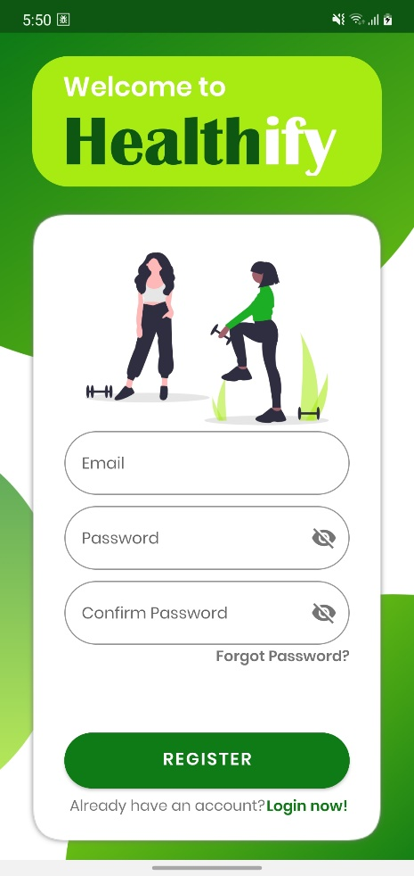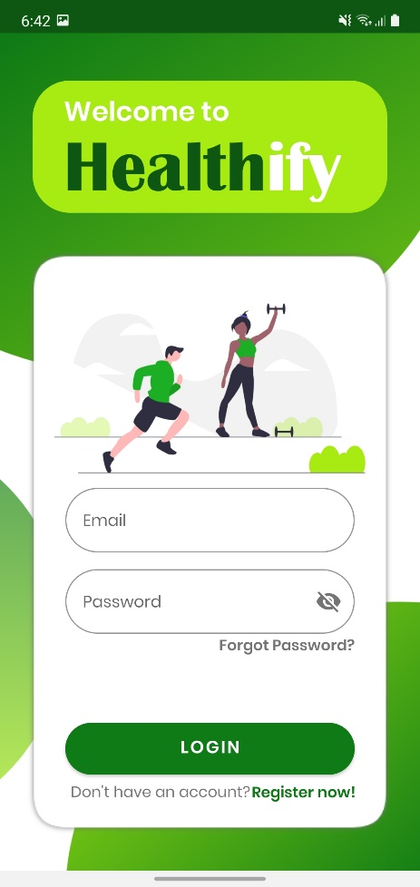

Figure : Login Screen

Figure : Register Screen

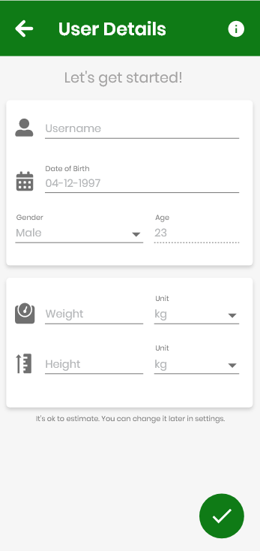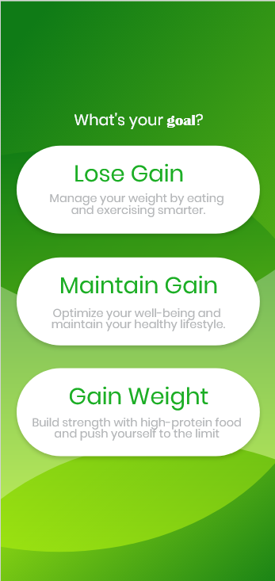

Figure : 'User Targets' Screen

Figure : BMI Test

#### Fitness Tracker

The users will also be able to log their daily physical activity through the proposed application. This will allow the application to track users’ progress/statistics and present them in forms of graphs or charts. Using this data, the app will give the user a visual representation of their progress, how much they have improved and how far they are to reach their goals. It will also allow the user to display their progress weekly or monthly, in addition, show a comparison graph of their progress from the previous week/month.

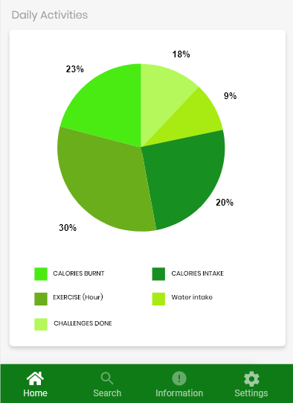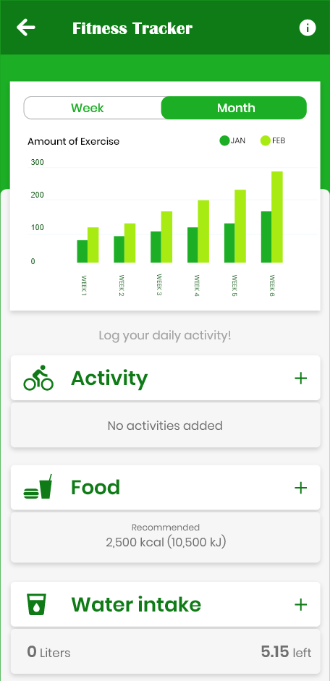

Figure : Fitness Tracker Screen (2)

Figure : Fitness Tracker Screen (1)

#### Sports and Exercise Encyclopaedia

The proposed application will have information regarding all sports to help promote exercise by giving helpful tips and advice. It will have a brief description of the sports and explain the benefits each sport will have on the body, how many calories players could burn on average, equipment you will require in-order to begin and the general costs you may need to think about (i.e., club membership etc). The application will also allow players to search for any local clubs or sport centres/facilities in their local arena or within a certain radius doing that sport. It will then display all the local clubs/facilities with the chosen radius, their address, contact information, and furthermore their location pinned on the map. This will be possible after the user provides the application their post code, which the application will use to filter the data and display the correct facilities. Aside from sport activities, the app will also contain other form of physical activities for those not interested in sports; for example, Hiking, Yoga and Running etc. In addition to all this, it will also recommend other applications dedicated to a certain sport or physical activity for those users who do not wish to join a club or go the facility due to busy schedules etc. For example, if a user wanted to do yoga, but did not wish to join a yoga club and wanted to do it at home, the proposed application will recommend the user some external application such as ‘Glo’ which is a mobile application dedicated to yoga and allows the user to practice at home. There will also be diagrams/illustrations provided for each exercise that can be performed at home, so the user’s do not injure themselves performing it incorrectly.

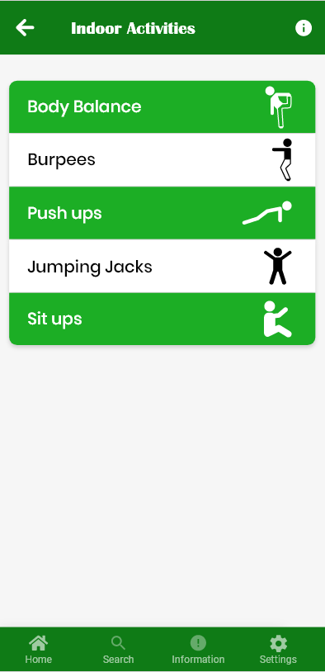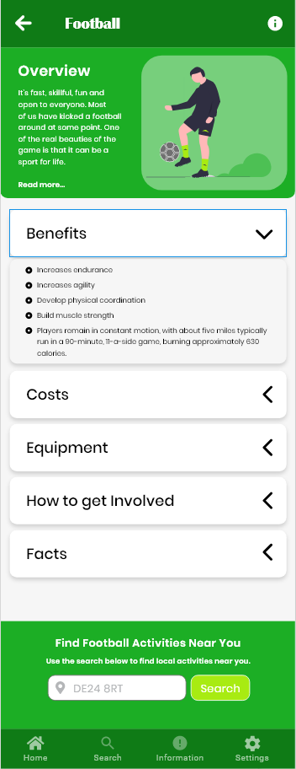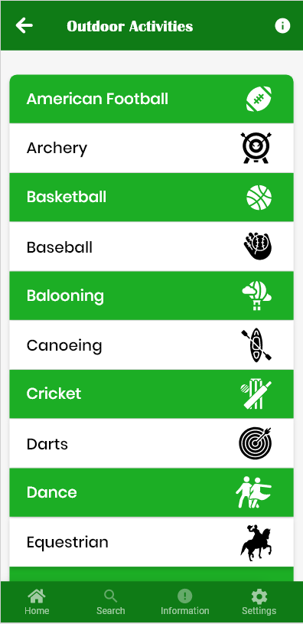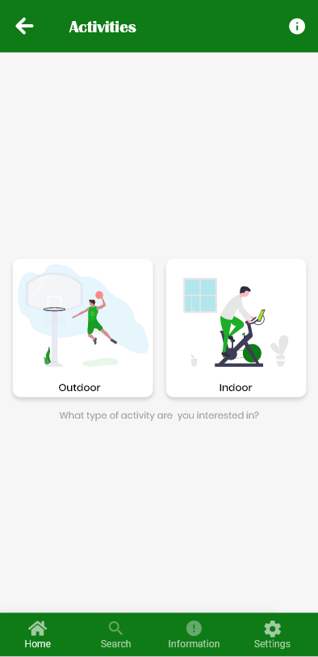

Figure : Outdoor Activities

Figure : Activity Info

Figure : Select Type of Activity

Figure : Indoor Activities

#### Daily Challenges

The proposed application will provide users daily challenges to help keep them motivated, which will earn them points when they complete them. At the end of each week, using the points, the users will be ranked depending on how many challenges they have completed. This will provide a competitive aspect which will motivate users more as they would want to be ranked higher than others allowing them to push themselves to gain as much points as they can weekly, resulting in them doing more exercise and staying healthy.

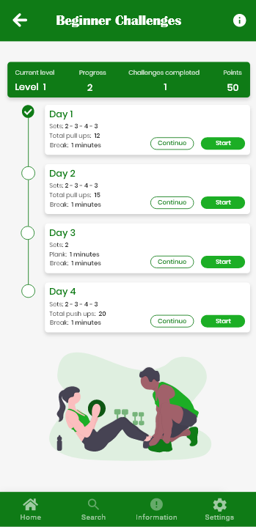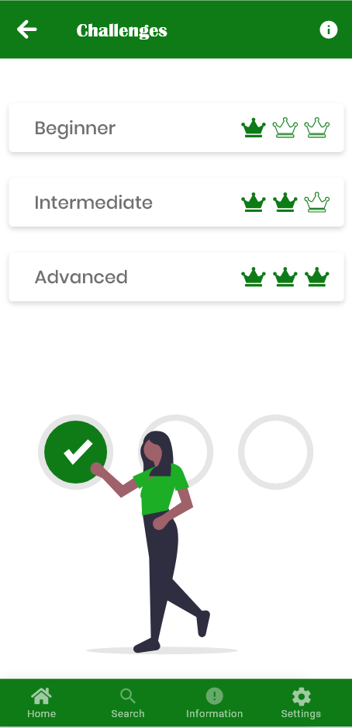

Figure : Daily Challenges Screen

Figure : Beginner Challenges Screen

#### Chat Room and My Story

The application will also include a chat feature to keep users engaged where they are able to talk to fellow users about their experience and help others or to gain advice. Interaction with other people will help users stay motivated to keep pushing themselves to reach their goals as they know they aren’t alone. In addition to this, there will be a blog type feature called “My Story” where users can share their success stories, their progress thus far or any helpful advice they would like to give new users.

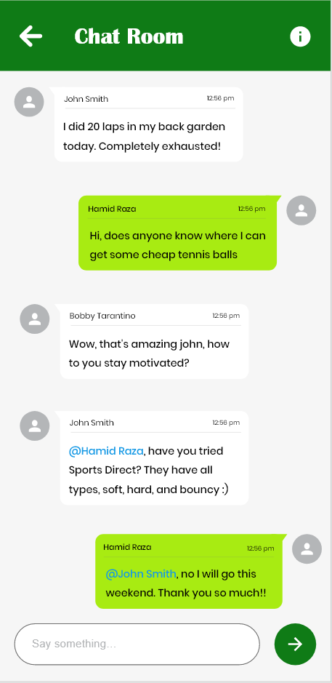

Figure : Chat Room Screen

#### Sleep Tracker

There will also be a “Sleep Tracker” feature which will help users manage their sleeping schedule; not having enough sleep can affect their motivation because if they are tired then they will most likely not want to exercise. According to NHS, “people who sleep less than 7 hours a day tend to gain more weight and have a higher risk of becoming obese”, therefore having the right amount of sleep can be very important to an individual’s health (NHS, 2018).

#### Water Intake Tracker

In addition to the sleep tracking function, there will also be a feature within the application which helps keep track of how much water they are consuming, as being hydrated is very important for exercising and a healthier lifestyle. The user will be sent a notification at every set interval to remind them to take a water break so they can consume the minimum amount of water the body needs. In a recent study, one of the negative impacts drinking less water will have on your body is amongst countless others, is weight gain (Henry Ford, 2020).

### Project Requirements

This section will detail the overall project requirements and resources needed for developing the proposed solution. It will also list the requirements that should be met in order for the proposed project to be considered a success.

#### Resources

The table below (Table 2) shows a list of general resources required for the project, as well as any additional requirements.

Table : Resources Required for the Project

|  |  |  |
| --- | --- | --- |
| **Software** | **Hardware** | **Other** |
| Android Studio IDE, Adobe Xd | Smartphone with Android 5.0+ operating system | Android Developers Documentation, Material Design Documentation, YouTube, Java and XML Docs |
| Firebase Realtime Database |  | Firebase Documentation, Google Account |
| GitHub Desktop |  | GitHub VCS Repository, GitHub Account |

##### Justification of Resources

A software development environment is required for the app to be developed in and Android Studio is currently one of the best Integrated Development Environment (IDE) for developing android applications (Alex mullis, 2020). Adobe Xd will be used to design the proposed application which will make things easier when developing it. A smartphone with android operating system with the minimum version of Lollipop (5.0) will be required to run the proposed application; older versions will not be able to support some of the application features. To aid the development process, the android developers and material design documentation (alongside others) will be used to help utilise and implement some of the proposed features successfully.

Firebase Realtime Database will be used to store all the user and the application data. Firebase Realtime Database updates information and provides the latest data in-real time thus the application will always be up to date with the latest data. Firebase documentations will be used to make sure that the firebase database is implemented successfully and works as intended. However, in order to use firebase database, a google account will be required.

A version control system repository will be required to store different version of the project’s source code. This will allow to rollback to an older version of the source code if the application breaks due to bugs or errors in the code which cannot be identified. Using the software ‘GitHub Desktop’ will make it easier to keep track of the changes made to the code as it provides the changes and the differences in the code visually, in addition to adding small comments or notes before you commit to the repository.

### Software Requirements

All the functional and non-functional requirements for the proposed application are listed below

#### Functional Requirements

The application must:

**FR1** – allow multiple user accounts.

**FR2** – allow the user to register.

**FR3** – allow users to sign in their accounts

**FR4** – allow users to sign out

**FR5** – store the user data in the cloud database

**FR6** – allow users to update their personal information (password, username etc.)

**FR7** – work out the users’ BMI test results using the data provided

**FR8** – show what their (healthy) weight should be

**FR9** – show what their daily calory intake should be

**FR10** – recommend the best exercise/sport to help them with their end goal

**FR11** – recommend the types of food which will help with their end goal

**FR12** – allow users to log their daily physical activity

**FR13** – keep track of users’ progress

**FR14** – display a graph to show their progress (weekly/monthly)

**FR15** – display information on any local clubs/facilities in the users’ area

**FR16** – display detailed information on all sports

**FR17** – display indoor and outdoor physical activities

**FR18** – display diagrams on how to perform certain exercises correctly

**FR19** – recommend external applications which specialises on areas the proposed application lacks on

**FR20** – provide new daily challenges

**FR21** – display users on a table, ranked depending on how many challenges they complete

**FR22** – allow users to join the “chat room”

**FR23** – allow users to send messages to each other in the chat room

**FR24** – allow users to post their motivational stories

**FR25** – allow users to see other users’ motivational stories

**FR26** – allow users to log their sleeping schedule

**FR28** – display if user is getting enough sleep

**FR29** – track amount of users’ water intake

**FR30** – send notification every set interval to remind user to drink water

**FR31** – work out how many calories they burned during the week

**FR32** – display a graph to show if they are on target/of target from their initial goal

**FR33** – The application features will not be available if the user is not signed in

**FR34** – Store information about all activities in the database

**FR35** – Update app when new sport/activity added

**FR36** - Update app when any sport/activity deleted

**FR37** – Update app when information on any sport/activity updated

#### Non-functional

**NFR1** – the design and layout of the proposed app should be user-friendly and professional

**NFR2** – the application should be easy to navigate through

**NFR3** – the colour theme should be appropriate for the target audience and should correspond, in addition to convey the message of the ‘health’ aspect of the proposed application

**NFR4** – use appropriate font that is easy and clear to read

**NFR5** - the colour scheme and the typography should be consistent throughout the whole app

**NFR6** – all types of android phones with the 5.0 operating system (or above) should be able to use the proposed application

#### Justification of Requirements

The software requirements listed above were decided based on the information gathered as part of the primary research and researching the existing solutions available.

Allowing users to create their own accounts are necessary in order to distinguish individual users and storing their data separately. Personalised accounts will help users identify each other more easily and help the application keep track as well as retrieve correct data for each user.

Storing the data in a cloud database will make sure the data is safe and can be accessed remotely, therefore the users can use the application on different phones and they will not lose their progress. This will also ensure users do not have access to other people’s personal information and is kept safe.

Getting the users’ BMI results are important because this will allow the application to help the users better by providing the necessary information they will need to reach their long term goal.

Having a visual representation of their progress will keep them motivated as they will be able to visually see the progress they are making over the course of the month. By providing competitive aspect where there will be a table of users who have completed most daily challenges set by the app, will allow users to push themselves further and help them stay motivated to reach their goal.

Allowing user interaction through “chat rooms” and “My Story” feature will allow them to keep each other motivated by sharing their success stories or by guiding others who are new to the application and need some advice.

### Project Schedule

The following section contains the planned project schedule outlining the estimation of workload for various phases and the tasks to be completed for the respective phase.

#### Project objectives and milestones

The projects main objectives and milestones are as follows:

* Research and review existing solutions
* Identity the limitations of the current solutions
* Create a prototype of the proposed solution
* Implement the proposed solution
* Test and evaluate the implemented solution

Table 3 represents the project milestones with the deliverables required for each milestone

Table : Project Milestones

|  |  |
| --- | --- |
| **Milestone** | **Deliverables** |
| Project Registration | Project Proposal  Project approval |
| Review Point 1 | Project Monitoring Form RP1  Project Planning Document  Ethical Issues Declaration Form |
| Review Point 2 | Project Monitoring Form RP2  First Draft of Context Chapter  Discussion on Next Draft – New Ideas Chapter |
| Review Point 3 | Project Monitoring Form RP3  First Draft of New Ideas Chapter  Discussion on Project Implementation  Discussion on Next Draft - Project Implementation Chapter |
| Project Submission | Project Report  Implementation Report |
| Demonstration (FYP Degree Showcase) | Implemented Solution |

#### Project Gantt Chart

Figure : Gantt Chart



IMPLEMENTATION or INVESTIGATION

Introduction

After documenting the proposed solution and analysis of the requirements in the previous chapter, this chapter will document the implementation phase of the software development lifecycle. This will include, the methodology followed, design and development of the proposed solution.

## Methodology

It is important to choose and follow a methodology prior to beginning development/implementing the project. Choosing the right methodology can be critical to successfully delivering projects on time.

For this project, the agile methodology was decided to be the most suitable. The agile methodology works by breaking the project down into several phases and allows to build on previously developed functionalities. Due to time restrictions, there is a possibility not all the features will be implemented. This makes agile the ideal methodology for this project as it allows for the requirements to be adjusted at any point in time throughout the entire development of the project.

### Agile Scrums

Out of the few agile frameworks, the framework chosen for this project is Scrum. It is a framework which helps people deliver products of the highest possible value while addressing complex adaptive problems.

Scrum projects consist of timebox events called sprint. Sprints are fixed time-period events which usually last between one and four weeks. A new sprint begins immediately after the previous sprints ends which creates consistency throughout the project.

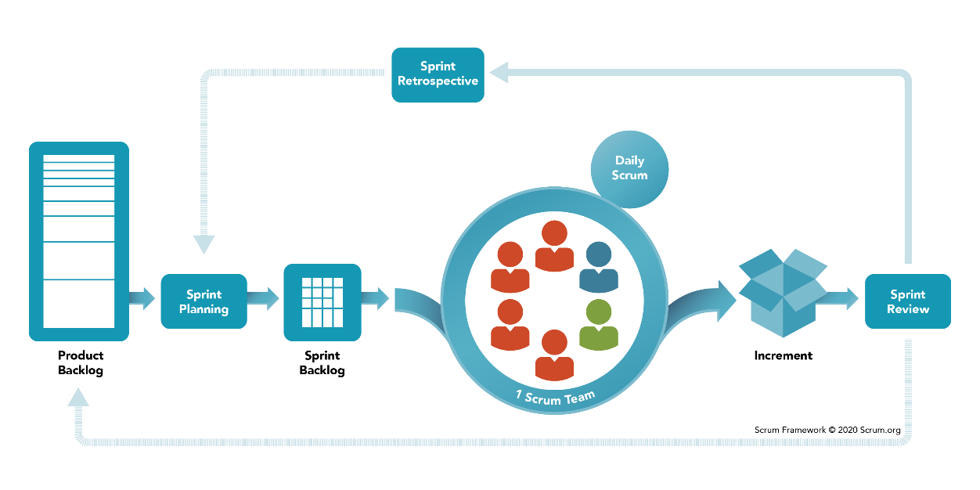Due to time restrictions and other coursework deadlines, only one week was spent on the implementation stage, which resulted in the project containing only one Sprint. To ensure there was at least one standout feature implemented in the application during the short period, planning took place to decide which tasks needed to be completed during the Sprint and how much time or effort they will require to be completed. Under normal circumstances, there would have been three/four Sprints, and when planned tasks are not completed during the Sprint, they are dragged into the next Sprint as the highest priority tasks.

Figure : Scrum Framework

## Design

### Use case diagrams

The figure 20 below shows the UML notation Use Case Diagram which represents the relationship between use cases to show how they would interact with each other. UML use case diagrams show the system and software requirements for an underdeveloped program, they provide a visual representation of how the system is expected to behave.

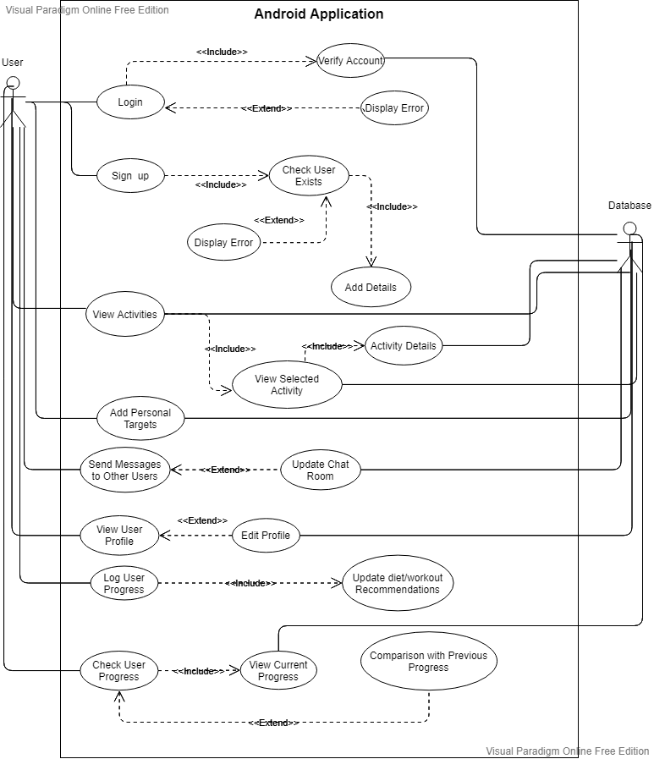

Figure : UML Use Case Diagram

### Database Structure (Firebase)

Google’s Firebase was chosen for storing and managing the back-end data of the proposed application. As discussed before, Firebase is a free cloud service which stores its data in JSON tree. It provides a variety of key features such as User Authentication using email/password, social media accounts (Facebook, Twitter etc) or even phone numbers; Realtime database where the data is synced in real-time and provides the users with the latest information across all the applications.

The advantages of using Firebase database are that the data will be stored online, thus it makes it easier to access anywhere, at any time. It makes the data secure so the users’ data will not be leaked or hacked into. The device will not require extra storage to store the data, unlike SQLite, which is another backend database for smartphone applications.

The figure 20, shows a screenshot of the most recent state of the Firebase (JSON) database. The higher-level nodes have been expanded to give and overview of the database’s structure. Currently, there are 2 main nodes that contain information of different types of physical activities, indoor activities, and outdoor activities. The data is nested under their respective nodes to make it easier for the application to differentiate the types of data being stored so it can easily read and write into the database.

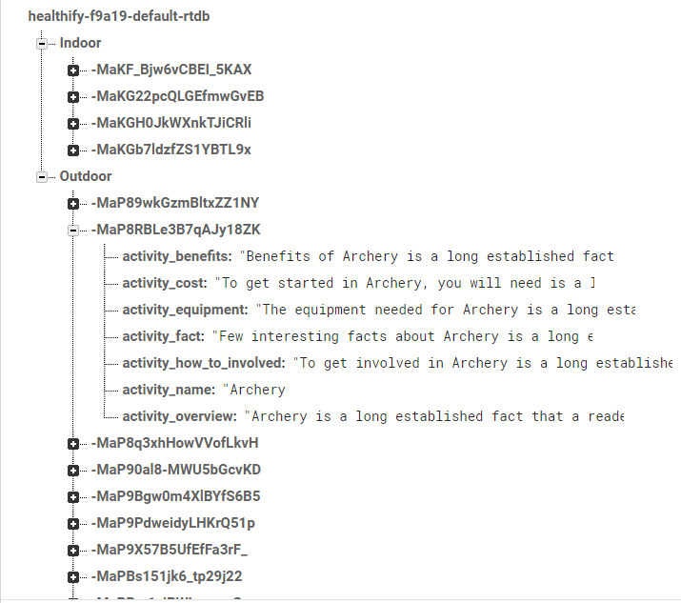

Figure : JSON Database Structure (Firebase)

### User Interface Design

#### Logo and Name

In order for the application to look and feel professional, it was important that a appropriate name and logo was chosen. Since it proposed application was aimed at helping improve the well-being and the overall health of its users, the name “Healthify” was chosen which gave off the feeling of helping you improving your lifestyle.

After deciding on the name, the next step was to create a logo. It was important that the logo also looked professional with the right colours and gave the visual representation of healthy lifestyle by choosing the appropriate colour theme. The colour ‘Dark Green’ was chosen as the primary colour, ‘Lime Green’ as the secondary, and white as adjacent. The word ‘health’ was left was in a different colour to make it stand out and relay the message of what kind of application it is. To make the users feel more welcomed, it was decided to add “Welcome to” on top of the logo.



Figure : Logo for the Application

#### User Interface

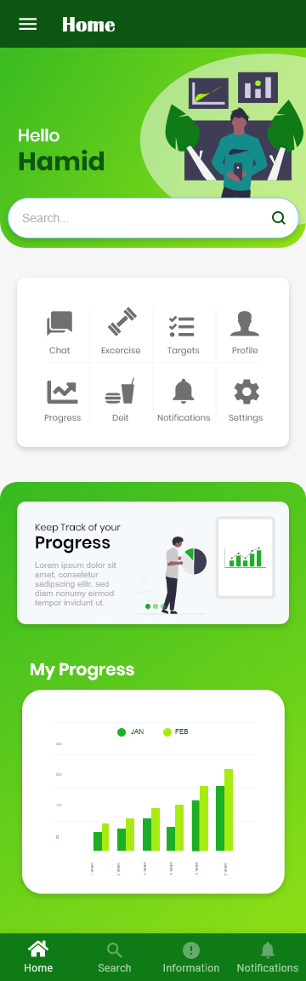User Interface designs were created in Adobe Xd to get an idea of how the proposed application will look like.

Figure : User Interface (Home Screen)

Figure 23 shows the design for the home screen of the application. The design contains a welcome screen with nice, colourful visual illustration and a bottom navigation. The bottom navigation was chosen over the side navigation (Drawer navigation) due to it being easier for the user to click the menu icons as everyone uses and press on their phone using their thumbs. However, because there were so many features present in the application, instead of adding them all at the same navigation menu, they were split into two different navigations. The bottom navigation being the main navigation which will be accessible throughout the application with the main one containing all the important features the user may always want access to, while the second navigation will contain all the extra features and will be available only on the home page.

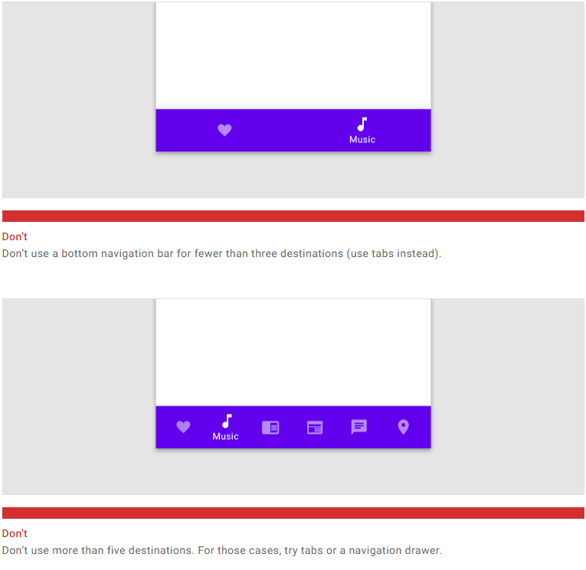

Figure : Google Material Guidelines - Bottom Navigation

While designing the user interface, Google Material Guidelines for design was taken into consideration to ensure the application looks professional to maximise user experience. For example, when designing the bottom navigation, it was recommended that the navigation should not contain less than three navigation destinations, and no more than four for a professional look. Thus, only four navigation destinations were included in the bottom navigation.

Apart from Googles Material Design Guidelines, Neilson’s 10 Usability Heuristics for User Interface Design (Neilsen, 1994) were also taken into consideration. The first heuristic, which the visibility of the system status was achieved by displaying the title of the page the user navigates to. The second heuristic is to make sure the language used match between the system and the real world, which was accomplished by terminology which was commonly used in sport related applications such as “Fitness Tracker” which should be simple for the user to understand. The third heuristic, user control and freedom were accomplished by giving users the option to cancel any input boxes or press backspace key on the phone to remove a text if they do not wish to send it. The consistency and standards heuristic is achieved by having a bottom navigation available on all screens and having a consistent colour theme throughout the application. Error prevention heuristic was attained by having validation on user input by displaying a little message which corresponds to the button/navigation item they press. The sixth heuristic which is recognition rather than recall was also accomplished by having different illustrations on different screens and helping them be unique and stand out from each other. The eight heuristic, aesthetic and minimalist design was achieved by providing straightforward dialogs and labels, avoiding irrelevant information. Helping users recognise, diagnose, and recover from errors, which is the ninth heuristic was accomplished by displaying error messages when validating user input.

### System Architecture

A standard system architecture for an android application is a three-tier architecture, which is made up of a presentation layer (or user interface layer), logic layer (or application layer) and data layer. The advantage of a three-tier architecture is that each layer can be developed or updated simultaneously without impacting the other layers.

The presentation tier provides the user interface, where the end user will interact with the application. Logic tier provides the core functionality and is known as the heart of the application. It is where all the information is processed and makes the communication between the data tier and presentation tier possible. The final tier, the data tier is where the information processed is stored by the application. Figure 25 shows a representation of the android application architecture.

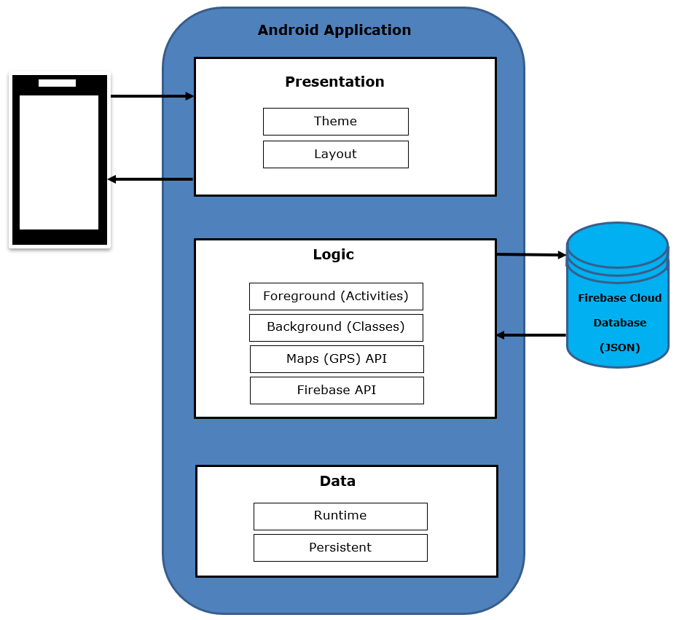

Figure : System Architecture Diagram

## Development

The following section documents the development phase of the proposed application. It will also detail any issues and challenges faced throughout the process.

### Version Control

Before the actual development of the application, it was important to set up version control for documenting, monitoring the process, in addition to having a back-up of the application source code in case of accidently breaking the application or losing the code.

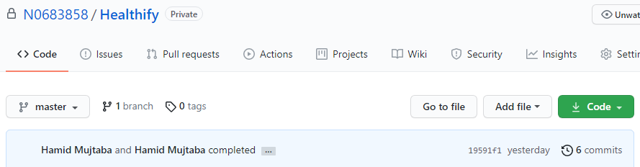

Figure : GitHub Repository for Project

At the end of each day, a commit was made to ensure the latest version of the source code is always back up.

### Scrum Board

To manage and keep track of all tasks which need to be done within each Sprint, an online tool called “Kanban Tool” was used for creating the Scrum Board. It allows users to create tasks, drag-and-drop them under different columns which represent the current state of the task. The board used for this project included 3 columns, “To Do”, “In Progress” and “Done” to help manage tasks easily. Each task will be moved under the “In Progress” column when it is being implemented, and then under the “Done” column once finished.

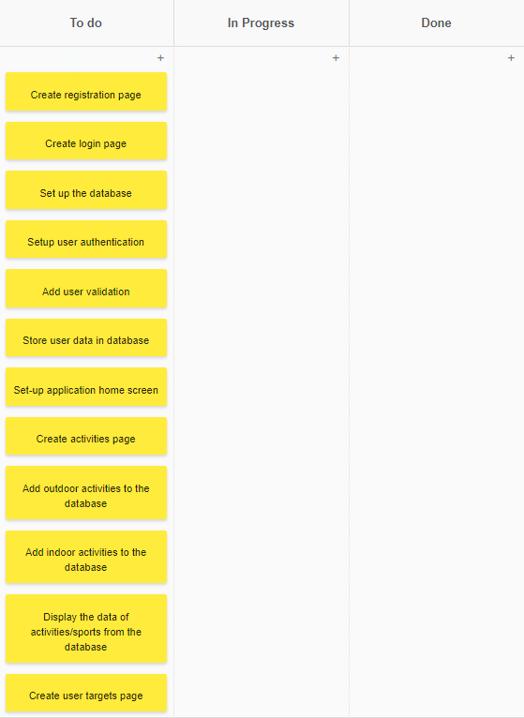

Figure : Scrum Board (Sprint 1)

### Sprint 1

#### Project Setup

The first step was to correctly setup the Android Studio IDE by adding the colour codes which will be used throughout the project in addition to adding external libraries to the project to help with the implementation of certain features. It was also important to specify the SDK version, so the application works on the indented mobile devices. Figure 28 shows the Gradle file of the project where the external libraries are added along with other important information.

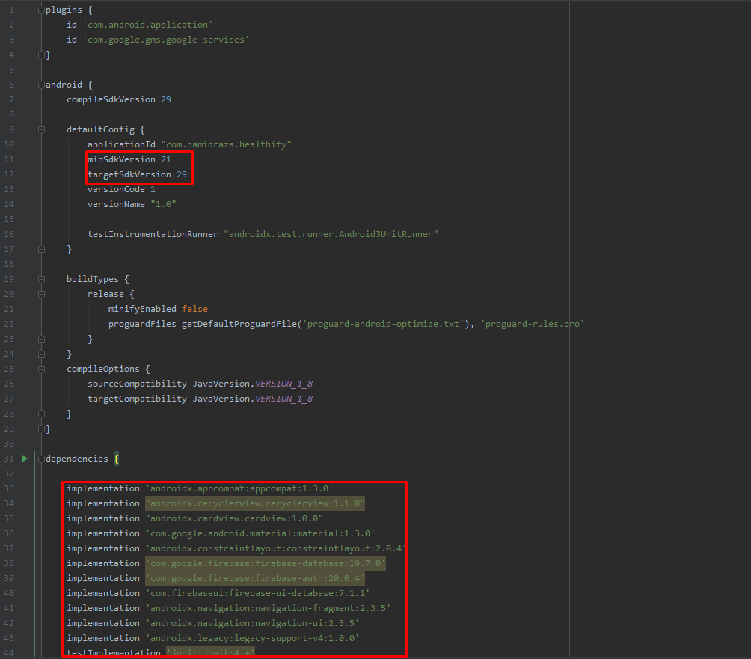

Figure : Project Gradle File

#### Database Connection

The next step was to set up the database connection with Firebase Realtime Database. Realtime database is one of the database Firebase provides which is synchronised in real-time and provides the latest data saved in the database. To achieve this, Android Studio built in Assistant tool was used to help manage this.

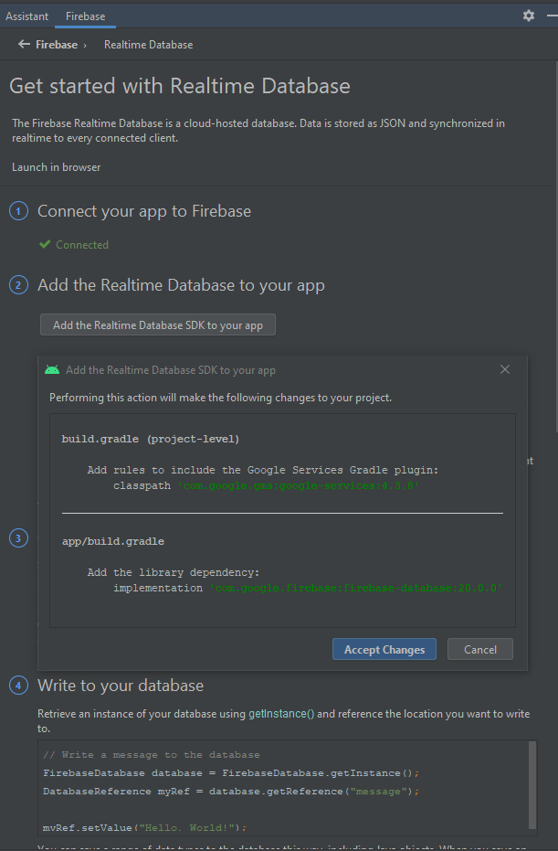

Figure : Firebase Database Setup

#### Account Creation

The next task was the implantation of the registration and login screens. To do this, 2 android activities were created, which generated one XML file and one Java file for each activity screens (Login and Register). The XML file managed the ‘User Interface’ elements, while the Java file managed how to handle the data/input provided by the user. After creating the input fields and buttons, ‘Firebase User Authentication’ was integrated using ‘Android Assistant’ to manage users. Using the Firebase User Authentication, the application was able to determine if the account details of the user exist, if not it will display an error and they will not be able to login to the application.

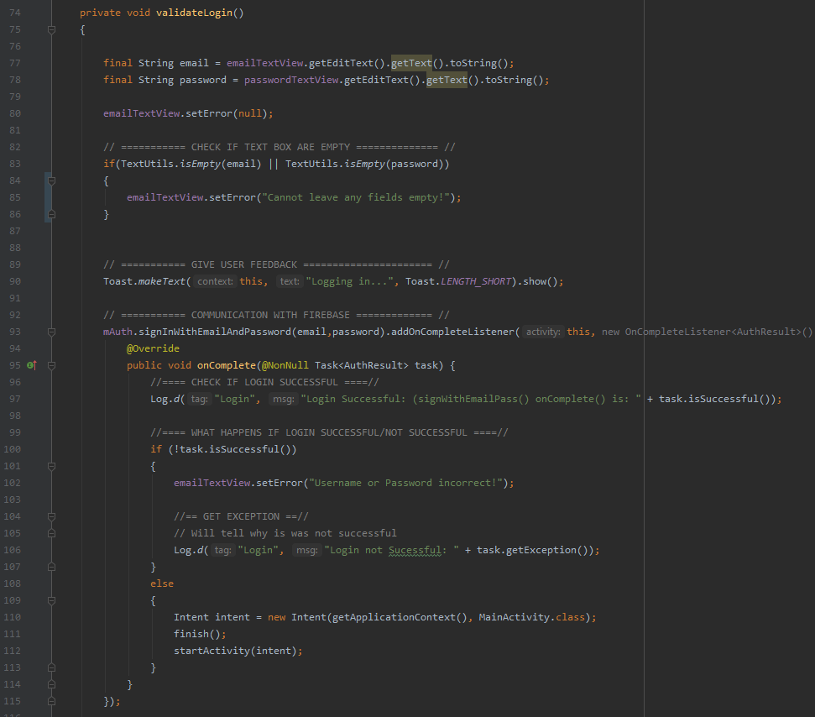

Figure : Login Details Validation

Similar Validation, which can be seen in figure 30, was added to the registration screen as well. It made sure the user details are appropriate (i.e., valid email address) before adding the details to the database.

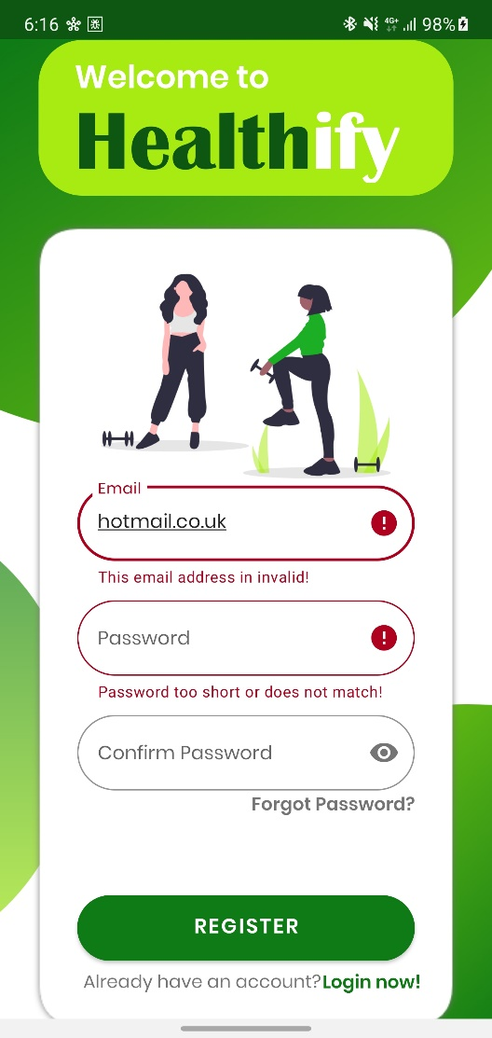

Figure : Validation on Registration Screen

After finishing the registration and login screens, the home screen was implemented, which was looked similar to the figure 23 shown in the ‘User Interface’ section.

#### Adding Sport/Physical Activities

The next main feature implemented in the application was one of the standout functionalities which makes this application different from the rest. First the information on all the different activities/sports was added to the Firebase Realtime Database, and then fetch the data from the database and populate a recycler view with the sport/activity names. When the users clicked on the activity name, it would display the activity in more detail.

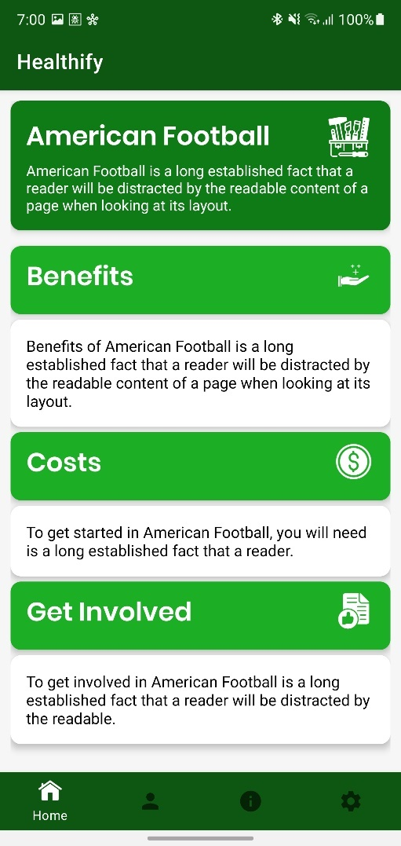 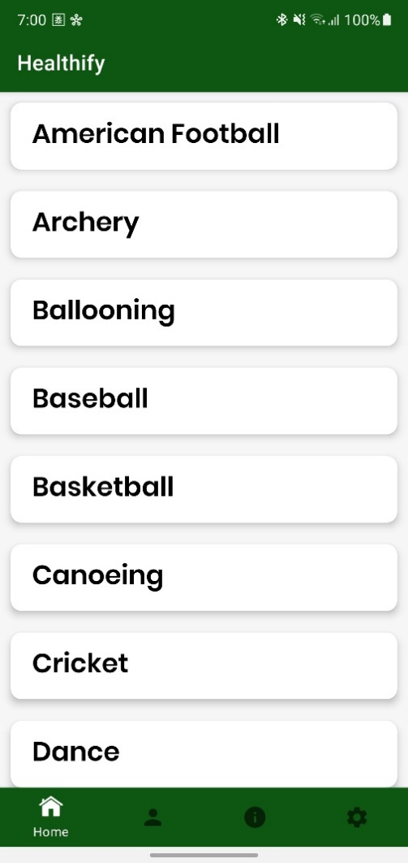

Figure : Detailed Activity Screen

Figure : Outdoor Activities Screen

#### Requirements Completed

##### Functional Requirements

Functional requirements that were completed during the Sprint are as follows:

**FR1** – allow multiple user accounts.

**FR2** – allow the user to register.

**FR3** – allow users to sign in their accounts

**FR4** – allow users to sign out

**FR5** – store the user data in the cloud database

**FR6** – allow users to update their personal information (password, username etc.)

**FR16** – display information on all sports

**FR17** – display indoor and outdoor physical activities

**FR33** – The application features will not be available if the user is not signed in

**FR34** – Store information about all activities in the database

**FR35** – Update app when new sport/activity added

**FR36** - Update app when any sport/activity deleted

**FR37** – Update app when information on any sport/activity updated

##### Non-functional Requirements

Non-functional requirements that were completed:

**NFR1** – the design and layout of the proposed app should be user-friendly and professional

**NFR2** – the application should be easy to navigate through

**NFR3** – the colour theme should be appropriate for the target audience and should correspond, in addition to convey the message of the ‘health’ aspect of the proposed application

**NFR4** – use appropriate font that is easy and clear to read

**NFR5** - the colour scheme and the typography should be consistent throughout the whole app

**NFR6** – all types of android phones with the 5.0 operating system (or above) should be able to use the proposed application

#### Issues and Challenges

One of the issues faced when implementing the login page was that even though the user information was correct, and the user details were saved into the database, the application would display an error. To figure out the reason for this, debugging was doing using Log.d() method to help see what error the getException() was displaying. This helped to determine the problem, which was the data users typed into the input fields were not being converted into strings before accessing the database trying to match user details. Another issue faced was that the recycler view on the sport/physical activities screen had too much space between each item/activity name. After doing some debugging and doing some research online, it was discovered there was an error in the code which kept pushing each item in the recycler view too far down.

Making the detailed view (figure 33) for each sport/activity was one of the biggest challenges faced. Initially, it was decided the boxes will expand when the user presses on them, however after trying different methods to try implement it, it did not function as intended, therefore it was decided to remove the “expandable” feature of the boxes and display them opened. In addition to this, there was also supposed to be a small option available for the users to find opportunities near them which would display the results on the map, however this required a lot of time and effort so was not possible to integrate into the application. Similarly, there were a few more functionalities implemented, such as ‘User Targets’ Screen but could not be finished off due to time restrictions.



RESULTS / DISCUSSION

Introduction

This chapter will analyse and perform tests to confirm the success of the application. It will then further analyse it and discuss the limitation and the results gained.

## Functional Requirements Testing

Manual testing was done to ensure the application features and functional requirements identified in chapter 3 work as expected. Before performing the following tests, the existing application data was removed to ensure the tests are valid. However, due to this project only containing one Sprint, not all of the functional requirements/features were implemented, thus only the limited functionality implemented can be tested.

Table : Functional Requirements Testing

|  |  |  |  |  |
| --- | --- | --- | --- | --- |
| ID | Test | Expected Result | Actual Results | FR/NFR Met |
| 1 | Try to sign in before creating an account | Should display an error as the account does not exist | Results were as expected | FR33 |
| 2 | Create a new account and login | Should add the user details to the database and user should be able to login | Results were as expected | FR2, FR3, FR5 |
| 3 | Login using an existing account | User should be able to login | Results were as expected | FR3 |
| 4 | Sign out | User should be logged out | Results were as expected | FR4 |
| 5 | User Detail Validation | Should display an error if user details not correct when creating a new account or logging into an existing one | Results were as expected | FR33 |
| 6 | Display all indoor activities | Should display all the indoor activities when user presses the “indoor activities options” on the “Activity Types” screen | Results were as expected | FR17, FR34 |
| 7 | Display all outdoor activities | Should display all the indoor activities when user presses the “outdoor activities options” on the “Activity Types” screen | Results were as expected | FR17, FR34 |
| 8 | Display additional (detailed) information on the activity clicked | When the user presses on the activity name, they should be taken to another screen which displays the activity in more detail | Results were as expected | F16, FR34 |
| 9 | Update app when any sport/activity deleted | When an activity/sport was removed from the database, it should not be displayed in the application | Results were as expected | FR35 |
| 10 | Update app when any new sport/activity added | When a new activity/sport is added in the database, it should be displayed in the application | Results were as expected | FR36 |
| 11 | Update app when information on any sport/activity updated | When information on any of the existing activities changed, the updated information should be displayed | Results were as expected | FR37 |

## Compatibility Testing

Compatibility testing was done after carrying out functional requirement testing, to ensure the application can be used on different mobile devices with different screen sizes and operating version (API versions). For an accurate compatibility test, it would be ideal to have used different devices, however, apart from the device which was used throughout the project (Samsung Galaxy Note 10 plus), it was difficult to get a hold of other devices, thus, a compromise was made using the built-in emulator in Android Studio which lets users simulate different devices.

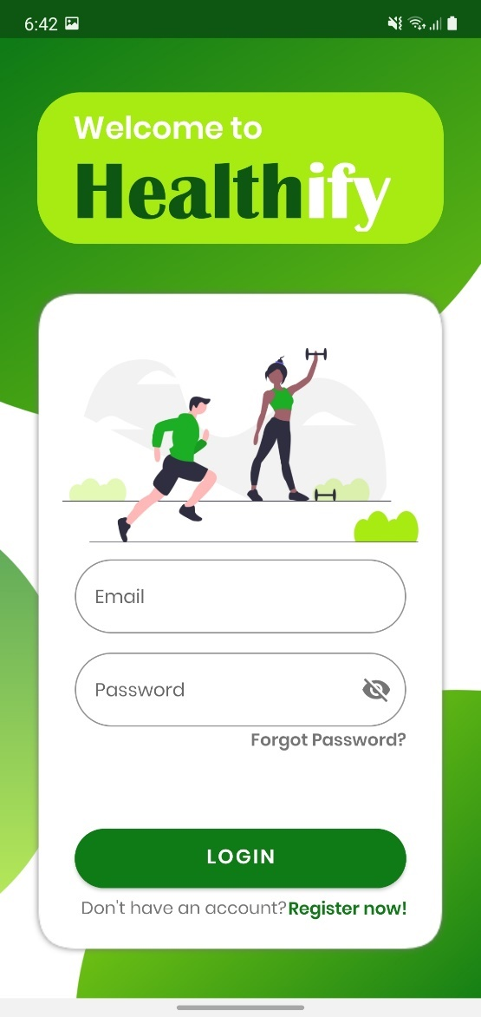

Figure : Application on Samsung Galaxy Note 10 Plus

The figure 34 shows how the application looks on Samsung Galaxy Note 10 Plus, which has the screen size of 6.80 inches, and runs on SDK version 30.

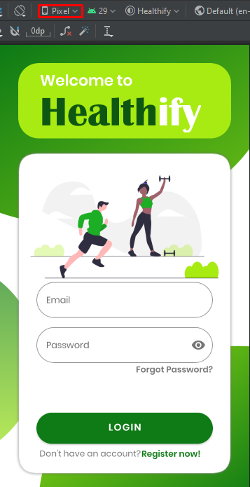

Figure : Application on Google Pixel

The above figure shows the application being ran on a Google Pixel device, which has the screen size of 5 inches and runs on SDK version 21.

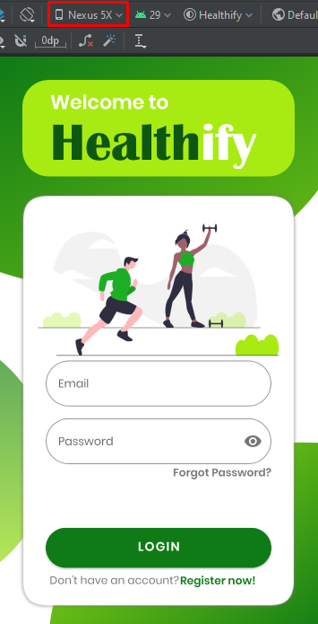

Figure : Application on Google Nexus 5x

Figure 36 shows how the application would look if it were run on a Google Nexus 5x, which has the screen size of 5.2 inches and runs on SDK version 23.

## User Testing

User testing is important for every project to ensure it fulfils and meets the needs of the users as intended. It will help determine anything which could have been overlook accidently or help identify any issues or new ideas with the application. However, it was not possible to get actual users to test the application, therefore, this section will present a test plan which would have been carried out had there been any users to test the application.

### Usability Evaluation

After the users have used the application and are familiar with the functionality and features, they would have been asked to fill in a questionnaire, to help determine the success and the limitation.

Table : Usability Questionnaire (1)

|  |  |  |  |  |  |
| --- | --- | --- | --- | --- | --- |
|  | Very Easy | Quite Easy | Neutral | Difficult | Very Difficult |
| How was the application to use overall |  |  |  |  |  |
| How easy was it to look for the information you were looking for |  |  |  |  |  |

Table : Usability Questionnaire (2)

|  |  |  |  |  |  |
| --- | --- | --- | --- | --- | --- |
|  | Over a month | Three weeks | Two weeks | One week | Less than a week |
| How long did you use the application |  |  |  |  |  |

Table : Usability Questionnaire (3)

|  |  |  |  |  |  |
| --- | --- | --- | --- | --- | --- |
|  | Definitely | Likely | Maybe | Unlikely | Very unlikely |
| Will you use the application again |  |  |  |  |  |
| Will you recommend the application to others |  |  |  |  |  |
| Did the application help you improve your lifestyle |  |  |  |  |  |
| Did the application help motivate you |  |  |  |  |  |

|  |
| --- |
| What feature did you like the best and why? |
|  |

|  |
| --- |
| Which feature did you not like and why? |
|  |

|  |
| --- |
| Which feature could be further improved? |
|  |

|  |
| --- |
| What can be done to improve the application? |
|  |

## Limitation of the Solution

It was hard to determine the limitation of the application without actual feedback from users, therefore it is difficult to analyse the areas it is lacking in. However, the few limitations identified in this section are from the experience of the author, throughout this document.

The first limitation would be getting active users, as there are countless health applications available that are a lot more popular, with better ratings. Ideally, people normally tend to download or use applications which have the highest ratings or the best reviews. Without enough users, competitive features will not work as intended, i.e., ‘Leader board’, the ‘Chat Room’ and the ‘My Story’.

There could be a limitation with the “Sports and Exercise Encyclopaedia” feature where users can use the GPS option to view any clubs or facilities in their area for the chosen activity/sport. It would be difficult and time consuming to add all the sport facilities and clubs across the country manually, therefore, some research can be done to look for external api or add a separate functionality where clubs and facility owners can add/advertise their clubs using the app.

Another limitation is the requirement of internet connection to access the full features and functionality of the application. Without any internet connection, users will not be able to login as a stable internet connection is needed so the application can communicate with the Firebase database. This could limit the number of potential users that would like to have access or would like to use the application, but cannot due to unstable internet connection.



CONCLUSIONS / FUTURE WORK

## Conclusions

The focus of this project was to promote a healthier lifestyle through a smartphone application by encouraging individuals to exercise more and help to implement healthy habits in their lives.

This was done by providing users with all the information they may need to live a healthier lifestyle at their fingertips and motivate them by keeping them engaged through features such as ‘Leader Board’, ‘My Story’ and ‘Chat Room’, so they know they are not alone in this journey. This will help users stay motivated, especially those who give up too early or want to quit because they find it difficult to change their unhealthy habits.

Users can now look up variety of sports or physical activities that interest them and know everything they may need to know from, how to get involved, to what equipment they may need to get started. In addition to this, it also has features to help them find opportunities locally; or the users can choose ‘indoor activities’ if they do not wish to go out and want to start by doing some physical activities at home. This tackles the issue of motivation highlighted earlier in the document due to lack of information available to the users.

The application also has features for those users who lie to log everything to see their progress over time. It keeps track of not only their physical progress, but the diet as well, in addition to recommending them how to safely gain, maintain or lose weight.

Putting the project into context, the proposed solution greatly improves on the features and functionalities highlighted in chapter 2 in addition to implementing features they were lacking in. Thus, it is believed the project can be considered a success as it would have met the initial aims and objectives had it been completely implemented as intended.

## Future work

Although the project can be considered a success, there are still areas for improvement as highlighted previously.

The first potential improvement could be to implement an offline mode for the application where users can use some functionality or features that do not heavily rely on the internet connection.

Motivational reminders

Add friends

Notifications

Exercise videos

## Legal, Social, Ethical and Professional Issues

This section should include a discussion of the four LESPIs and the way in which you project has/will/could impact on each.

## Synoptic Reflections

This section will comprise of a reflection on the project in relation to employment aspirations and the skills that you have developed towards this through engagement with the project.

ReferenceS

Schwaber & sutherland. 2017. WHAT IS SCRUM?. [Online]. [24 May 2021]. Available from: https://www.scrum.org/resources/what-is-scrum

Ibm cloud education. 2020. Three-Tier Architecture. [Online]. [25 May 2021].

Available from: https://www.ibm.com/uk-en/cloud/learn/three-tier-architecture#:~:text=Three%2Dtier%20architecture%20is%20a,associated%20with%20the%20application%20is

Bibliography

Educative. 2016. What is Firebase?. [Online]. [25 May 2021]. Available from: https://www.educative.io/edpresso/what-is-firebase

Jakob nielsen. 1994. 10 Usability Heuristics for User Interface Design. [Online]. [25 May 2021]. Available from: https://www.nngroup.com/articles/ten-usability-heuristics/

Appendix A: Project Planning document

# A1 Introduction

The chosen topic for the project is a mobile application aimed at individuals who have interest in Sports. The application will try help individuals who are not familiar with clubs by providing all necessary information and help they may need to get started. The reason behind the chosen topic is related to physical health issues in the UK due to lack of exercise which will be discussed in more detail later. Thus, the application will aim to encourage more people to get involved and help them find opportunities in their area. Health issue is the main problem this project aims to tackle and provide a potential solution for. According to the NHS (July 2012) a lot of health issues in the UK are due to the lack of exercise which is “as deadly as smoking”. It has been estimated that “one in 10 cases of heart disease (10.5%) and just under one in five cases (18.7%) of colon cancer in the UK” often can be due to lack of exercise. In 2008, inactivity caused more than 5.3 million of the 57 million deaths estimated worldwide (NHS 2012). Lack of exercise can also cause your bones to become weak, risk of diabetes or hypertension (Kristin Davis, n.d).

The focus of the project is to try creating an application which will encourage individuals to be active by joining their local clubs or sport facilities as a means to stay fit. The purpose of the application is to store data on variety of sport clubs/facilities, opportunities (includes GPS feature) and all there is to know about getting for the user all in one place. Often people want to join a local club etc but do not have enough information about the clubs or their location which this project will help resolve. Currently, there are no solutions in the app market or online that offer same functionality or features to the proposed project.

However, there are a few resources which help achieve similar results. For example, using Google maps to locate suitable local clubs or facilities and then receive directions. Facebook is another platform which helps achieve similar results. Facebook has a functionality which allows its users to create Facebook pages where they can post updates and events. After doing some research, there were few pages that can be found on Facebook who advertise sport clubs/tournaments providing opportunities to people, such as “Sunday League Football (West Midlands Only)” page. ‘Sunday League Football’ also advertises kits players can buy at a very reasonable price. Another online resource which provides information are sport associations such as the FA (Football Association) website; where you can find all there is to know about Sunday league football clubs. The user can find their city’s Sunday league (Men/Women and different ages), and all the teams currently registered; among other things, they also keep track of match results and player/club statistics. There is an app called “Match Report Pro” on Google Play/App Store which provides similar features and functionality compared to the proposed project; It is free to install. The application allows its user to create an account (usually the club manager) and register their team on the platform. The user will have the ability to manage their team from the app as they can add the player information, register match dates (when the match date approaches it will send them a notification); ‘Live Scoring’ system, Team statistics & individual player stats. The app has a built-in function which will automatically write match report for the user. The user can also communicate with the team sending them messages and chat using the app. There are also sport facilities who post leaflets to advertise around the local area and often provide indoor sports opportunities, such as ‘DW Fitness First’, ‘David Lloyd’ and ‘Moorways’ etc who offer indoor boxing and swimming lessons.

# A2 Amins and Objectives

This project aims to create a sports application intended to encourage individuals to partake in sports of their choice. The projects aim to achieve this by the following:

1. Research/Learn to develop in Android Studio

Do research and learn how to implement the features needed for the application. Without doing research, it will prove to be difficult later and will likely be a big setback for the project. The research should take no more than 2-3 days maximum.

1. Provide people with all the information about local clubs

Try implementing features and functionality which will make people look into local clubs and all the information they may need to get into their chosen sport. This may take some trial and error to meet the user requirement. Majority of the time will be used achieve this.

1. Develop a user-friendly UI

Implement a very simple user interface which is easy to use. Will attract more people to use the application compared to an application which is very complicated to use, so after some time, users will get frustrated and not use it. This may take around a week.

1. Find a way to safely store user data

It will be important to have a secure way to store user data by implementing a database, so no one else has access to it. Also, this will make sure the user data is saved so they will not have to keep making an account each time they use the app.

1. Provide map feature

Implement a GPS feature which shows the location of the clubs which will make it easier for the user to locate

1. Intergrade functionality for variety of sports

Have a variety of sport options for the user because everyone has different likes and dislikes, so instead of forcing a specific sport, it will be good to have a variety to choose from.

1. Add functionality for individuals to leave reviews

# A3 Tasks and Deliverables

There are a few tasks and deliverables which need to be completed in order to meet the aims and objectives set. The tasks and deliverables include:

1. Research

* Research how lack of exercise is affecting individuals and the main reason behind it
* Research existing solutions currently available to see what their strengths and weaknesses are and try to add the improved functionality in the app
* Research Android Studio using their documentation and online tutorials to help develop skills
* Research how to design GUI
* Research way to test the application to ensure the code has no errors and it runs fine
* Research how to set up database for mobile application using Android Studio

1. Create a repository for version control which will enable to backup all the data and keep it safe, so it is not lost
2. Develop prototype of the application by putting together all the knowledge gained from the research
3. Identify requirements

* Identify functional requirements for the application
* Identify Non-functional requirements
* Milestone: Requirements gathered

Dependant: Functional and Non-functional requirements

1. Analysis

* Create model use cases

Dependent: Requirements gathered

* Create class diagram which will show the structure of the system and classes it will need Dependent: Requirements gathered
* Create sequence diagram which will show the interaction between objects and classes
* Milestone: Analysis complete

Dependent: All Analysis tasks

1. Database Design

* Create ERDs (Entity relationship diagram) which will show the relationship between entities within the application

Dependent: Analysis

* Create DFDs (Data flow diagram) which will show the data flow within the application Dependent: Analysis
* Normalisation of the data which will allow to reduce dependencies

Dependent: DFDs & ERDs

* Milestone: Database Design completed

Dependant: Database Design tasks

1. Design

* Create a paper prototype of the application

Dependent: Analysis and Database Design

* Milestone: Design completed

Dependent: All design tasks completed

1. Implementation

* Create user login for Player user, Club user and Admin

Dependant: Design and Database Design

* Create Signup for 2 types of users

Dependent: Design & Database Design

* Create UI for the Player user – Dependant: Design
  + Home interface
  + Profile interface
  + Local sport facilities interface
  + Competitive clubs’ interface
  + Non-competitive clubs’ interface
  + Quick Match
* Create UI for Club user – Dependant: Design
  + Home interface
  + Profile interface
  + Add Club static interface
  + Add club league interface
  + Upload Club photo interface
* Create UI for Admin – Dependant: Design
  + Home interface
  + Manage player user interface
  + Manage club user interface
* Implement the backend for all 3 UIs - Dependent: Database, Analysis & Design
  + Backend for Player user
  + Backend for Club user
  + Backend for Admin
* GPS functionality which shows the location of the club- Dependent: Design
* Milestone/Deliverable: Player user part complete

Dependent: Creating UI and Backend completed

* Milestone/Deliverable: Club user part complete

Dependent: Creating UI and Backend completed

* Milestone/Deliverable: Admin part complete

Dependent: Creating UI and Backend completed

1. Testing

* Create test suites using Android Studio to make sure the application works fine and meets the project requirements

Dependent: Login/Sign up being completed

* Get colleagues to test it to make sure it meets the user requirements

Dependent: Implementation being completed

* + Milestone: Testing complete

1. Project Report
2. Deadline from other modules

Once the application is completed and tested, it would be uploaded to Google Play which is Android App store so users can freely access it. Also, have local clubs and individuals use the application and receive their feedback. However, this is out of scope for this project due to having deadlines for other modules.

|  |  |  |
| --- | --- | --- |
| **Milestone** | **Date** | **Deliverables completed** |
| Review Point 2 | 6/11/19 | 1,3 |
| Tutorial 3 | 20/01/20 | 2,4,5,6,7 half of 8 |
| Tutorial 4 | 01/03/20 | 8,9 |

# A4 Gantt Chart

# A5 Resources

The main resource which will be used throughout for the project will be Android Studio which is an IDE for android development. It is Java integrated development environment which provides the user which drag-and-drop tools. This makes it easier for the developer to work on the interface for the application they are trying to create; it also gives the user a visual representation of how the application will look on a mobile phone. Android Studio is of the best android development IDE (Adam Sinicki, 2018), one of the reasons for this is because it provides the user with a virtual device so they can execute and run the code to see how the application would look along with how it works. The application will be implemented using ‘Android Java’ programming language which is very similar to Java because it is Java based and there are large Java libraries supported in Android (Java).

The project will aim to target Android platform instead of iPhone (IOS). The main reason for this is because according to the statistics, Android share 74.45% of the market while IOS shares only 22.85% (Martyn 2019). This shows that the project will be able to influence a large number of audiences, compared to IOS. For the storing data, the application will use a database called Firebase which is a cloud-based database. The application will also use ‘Flutter’ which is a Google Framework. The project will use Flutter to assist with implementation of the user interface as Flutter has its own UI system. The project will use version control to ensure the work is safe and has been backed up in case of any unforeseen incidents. To achieve this, the version control which will be used is called ‘GitHub’. GitHub is the most used version control system amongst developers as it is very versatile and has many useful functionalities. Once the project has been finished, it will be then uploaded on ‘Google Play’ for users to access which is the platform where android users download apps from.

There are various online resources which will be used to assist with the completion of the project. Udemy and YouTube will be used to watch tutorials on how to implement features/functionality for the application and to increase the knowledge on mobile development. Udemy is an online platform for online courses, which teaches its users from the basics to the advanced techniques of the topic. YouTube is a media platform where the user can find any type of video they wish to see. There are also Mobile Application labs which provide information on many useful functionalities which could be used in the project. The lab tutor for the mobile application module along with my personal tutor are also available to assist with the project and give helpful advice when needed. Friends and colleagues who are familiar with android development can also be source of information if there are issues while working on the project. For designing the user interface paper prototype, ‘Fluid UI’ is a very helpful online platform which allows the person to drag and drop UI features such as buttons, text boxes etc, making it very easy to design a prototype. ‘Material Design’ is a website which will assist when designing GUI for the application as it contains different layout and design ideas for mobile applications, websites and desktop consoles etc. The only hardware required for the project would be a mobile phone with Android OS installed.

# A6 Project Risks

|  |  |  |  |
| --- | --- | --- | --- |
| **Potential Risk** | **Probability**  **(Out of 5)** | **Cause of the Risk** | **Potential Solution** |
| Not meeting requirement | 1 | The functionality and features aren’t meeting the project requirement | Get in touch with local clubs/friends and colleagues and see if they are willing to give feedback |
| Project too complicated | 2 | Making the project way too complicated and unrealistic to complete in the given timeframe by adding too many/complicated features | Discuss with PT if the features are realistic or unrealistic to create. Start by working on the easier features and leave the complicated ones to last |
| Users do not use the application | 0 | There might be some features the application is lacking | Get some feedback from friends (who play sports), PT, colleagues and maybe even local clubs. |
| Interface is very confusing and complicated to use | 3 | Due to lack of experience making application, it could prove to be difficult to add all those features in a user-friendly way | Try to get advice from ‘Mobile Application’ module lecturer and PT. Don’t add too many features on a single interface, instead try to have a verity of interfaces for different features to make it simple to use for the user |
| The project doesn’t get finished on time | 2 | Due to having lots of work to do for other modules, there isn’t much time to work on the project | Manage time well by using free sessions/time efficiently and make a weekly timetable to divide the time appropriately between the modules. |
| Work gets deleted | 1 | Accidently delete the code file, or laptop/computer stops working | Make sure the worked is backed up and use source control (version control) such as ‘GitHub’ to keep work safe and backed up |
| Database is not set up properly | 3 | The database isn’t implemented properly so the app cannot store user information, such as login info when they register. This will result in the app not functioning properly plus them having to make a new account over and over. | Do some testing while implementing the app features. Do some research on how to set up the database properly in ‘Android Studio’. |
| Home computer breaks down | 2 | The computer at home stops working due to unforeseen circumstances | Come to university early so you can use their facilities i.e. computers |
| Error in the Code | 5 | Not implementing test suites to test the code for errors etc which could result in the application being full of bugs and ruin user experience | Research how to write test suites in android studio and what resources are available online to help achieve this |

# A7 Legal, Social, Ethical and Professional Issues

There are many legal, social, ethical, and professional issues which need to be taken into consideration while working on the project. One of the legal issues which may affect the project is General Data Protection Act (GDPR) 2018. Data Protection Act 2018 is the updated version of Data Protection Act 1998 where the personal information used by organisations or businesses need to be, “handled in a way that ensures appropriate security, including protection against unlawful or unauthorised processing, access, loss, destruction or damage” [1]. This act will affect the project as the application will store the users’ personal information such as, name and address etc, thus, while implementing the application, it is important to make sure the user’s data is safely protected. One way to achieve this is by making sure no one has access to user data except the user or the admin. Also, only the user can see their own personal information. Computer Misuse Act is another legal issue which will affect the project. This act ensures the personal data of individuals is safe and protected from “unauthorised access and modification” [2]. The solution to this is like the previous one, by making sure unauthorised users do not have access to other people’s details. In addition to this, the data can be stored in an online database instead of the phone. This will keep the personal information protected and away from unauthorised personal, so they will not have any means to access it. One other legal issue which may need to be taken into consideration is Freedom of Information Act. However, this will not have an impact on the project because the Freedom of Information Act only covers public authorities [3].

There are a few social issues to be taken into consideration such as the impact on the society i.e., families, education, workplace etc while working on the project. The project may have a positive impact on families as they may download it to get into sports/exercising and aim to improve their wellbeing together. It can also affect educational sector as schools may encourage student to download the application, so they make take interest in sports and look after their health from a young age, as the lack of exercise because a habit as you get older and become lazier which increases the chance of health problems. It may have an influence the youth and encourage them to get out of their houses instead of using their phones or computers at home all day. This will help decrease the risks of social isolation as they are going to meet new people and socialise by making new friends. Cyberbullying can be another issue which may affect the project as one of the potential features to improve the project could be to add social media side where people talk about their experiences with different clubs and give them a rating out of. However, this could result in cyberbullying, for example if someone give a poor rating or leaves a negative comment about a club, the staff or the members of the club could be offended which could result in cyberbullying.

One of the ethical issues which may affect the project is misuse of information such as identify theft and offensive material. There have been many cases of identity theft where people have had unauthorised access to someone’s detail or using social media. The application will store user’s personal information, thus if someone else other than the user had the access to it, their identity can be stolen; someone can stalk them as they will have their address details. Therefore, it is important to keep the user data safe as mentioned previously in the legal issues. Someone can make a club account as a prank and add offensive material or inappropriate location details instead of a sports club or facility. Thus, it is important the admin monitors the clubs being added, the potential solution to this can be that before the club/facility details are added to the club, the admin will have to approve it, if it is declined, then the data will not be added to the app. Ethical issues such as Safe Guarding (DBS) doesn’t impact the project as it doesn’t involve anything which may put anyone’s health in risk, neither does it involve working with kids.

There are professional issues which may also influence the project; thus it is important to unsure the British Computer Society (BCS) Code of Conduct is taken into consideration which lists how to keep your work at the professional standards. Under the ‘Public Interest’ section, it is mentioned to ensure professionalism, your activities should not discriminate “on grounds of, sex, sexual orientation, marital status, nationality, colour, race, ethnic origin, religion, age or disability” [4]. This could have an impact on the project as there could be clubs listed in the application who discriminate against a certain type of people, or if the application for example, had the options where it specifically asked for their race and filter the sports, they can do depending on what race they chose. Thus, it is important when creating the application, not to include any features which may discriminate, and include an option for users to report any clubs they may feel are discriminating. In the code of conduct, it is also stated to keep professional competence and integrity in mind, meaning respect other people’s alternative news and accept criticism with an open mind. This can be applied to the project, so when a colleague/friend or PT gives some criticism, do not take it to heart and be upset about. Instead use that criticism to improve the project further. When working on projects generally, sometimes unexpected issues can arise which could have a big impact on the project and effect its progress, therefore, it is important to react to any unexpected situation appropriately to show professionalism.

# A8 References

nhs.co.uk. (2012). Lack of exercise as 'deadly' as smoking. [Online]. [21 October 2019]. Available from: https://www.nhs.uk/news/lifestyle-and-exercise/lack-of-exercise-as-deadly-as-smoking/

Davis, K. (n.d.). The Effects of Lack of Exercise on the Body | Livestrong.com. [online] LIVESTRONG.COM. Available at: https://www.livestrong.com/article/351679-the-effects-of-lack-of-exercise-on-the-body/ [Accessed 28 Oct. 2019].

Adam sinicki, A.S. 2018. Best Android developer tools for getting started or levelling up your dev skills. [Online]. [28 October 2019]. Available from: https://www.androidauthority.com/best-android-developer-tools-671650/

Martyn casserly, M.C. 2019. IPhone vs Android market share. [Online]. [28 October 2019]. Available from: https://www.macworld.co.uk/feature/iphone/iphone-vs-android-market-share-3691861/

[1] GOV.UK. (n.d.) Data protection. [online] Available at: https://www.gov.uk/data-protection

[2] BBC. (n.d). Ethical, legal and environmental impact - CCEA. [Online]. [4 November 2019]. Available from: https://www.bbc.co.uk/bitesize/guides/z8m36yc/revision/5

[3] Ico. (n.d.) What is the Freedom of Information Act?. [Online]. [6 November 2019]. Available from: https://ico.org.uk/for-organisations/guide-to-freedom-of-information/what-is-the-foi-act/

[4] Bcs. n.d. BCS Code of Conduct. [Online]. [6 November 2019]. Available from: https://www.bcs.org/membership/become-a-member/bcs-code-of-conduct/